Abstract

As the business sectors progress alongside technology, the tourism industry also grows, aided by the Internet. Yet, it does not grow as fast as one would like, especially in the developing markets. Such companies do recognize the power of the Internet, but make only a half-hearted attempt to utilize it. They do not employ the proper resources needed to cultivate the online market. A proper web-based solution could easily increase the traffic these companies receive. One such solution is Online Tour Guidance System. The developed product ‘Glacier Lake’ is an example of a proper solution that includes all the necessary functionalities. In this paper, I present how such a system is developed using proper research, planning and implementation of available tools, methodologies, and web technologies.

Introduction

Tourism is the world’s largest civilian industry and can be accounted for significant amount of the world’s GDP. Its growth and economic significance are undoubtedly recognized all over the world. In our current day and age, its capacity for growth and scalability, global reach as well as being an ideal enterprise to generate not only domestic income but, rather, global revenue is highly acknowledged all over the world. But the truth of the matter is that, while its potential is understood, the maximum capacity of tourism is yet to be reached. (Bogdanovych A., Berger H., Simoff S., Sierra C. , 2006)

With the advent of the World Wide Web, 21st Century technology has progressed rapidly over the years. In just a few decades, the world has come from physical forms of communication like letters/mails to a time where any other forms of communication besides digital is considered obsolete. Technology has grown so rapidly, so exponentially that something that didn’t even exist 20 years ago has become the major focus of our modern lives. However, this sudden growth or burst is only temporary and will eventually slow down or as predicted by Moore’s Law.

Moore’s Law is an observational prediction that states that, “the number of transistors in a dense integrated circuit doubles about every two years.” which has proven to be accurate for several decades in technological advancements. It also predicts that such a growth will eventually die off and reach saturation. Despite all of this, we cannot deny that technology has touched every aspect of our lives and the way we do things. It has provided us a means to communicate and share information easily and efficiently – to reach out globally. This has played no small part in helping tourism grow into such an enormous sector. This ability to reach out to global markets without having to expend physical resource is invaluable to the industry.

With that being said, it has yet to reach the maximum capability it has to offer. This is even more so in the context of a country like Nepal, which has enormous potential to rise as a tourism-based country but is being severely underutilized in actuality. Still, online tourism is the way to go and the path ahead lies through utilizing modern technology.

My Online Tour Guidance System is an initiative to help further digitalize the tourism industry and implement current innovations as well as my part in the growth of online tourism.

Project purpose

Online Tour Guidance System is simply a web service created to help people to travel. As its name suggests, it aims to help users to easily and efficiently browse destinations and book a tour as well as providing various other functionalities. Glacier Lake © is the name of the web service and is built around a Database system focused primarily on the end-user. For the uninitiated, end users are the type of users who use the application or the finished product, and are unconcerned or unaware about the design and internal structure of the database. They access the database from the terminal end and are primarily focused on getting the job done.(whatisdbms, 2016)

Glacier Lake © is goal-oriented over being technicality focused and keeping that in mind it provides users with a simple and easy to use interface. It provides an attractive design that allows users to view various destinations and book them according to different packages of their preference.

The primary goals of Online Tour Guidance System are as follows-

1. To allow users to view places of interest that are suitable for a tour.
2. To allow users to view helpful content with regards to travelling.
3. Create a responsive and easy to use user interface, suitable for multiple platforms.
4. To create a PHP and MySQL oriented web service that can store, update or delete data in multiple databases.
5. To create a user and administrator based login system that provides certain privileges to registered users and a host of other privileges to administrators.
6. To allow registered users to book a tour and checkout through an online payment service.
7. To allow registered users to rate and comment on a destination to share their experience and satisfaction.
8. To allow user to upload photos of their travels as a showcase in the gallery area.
9. To improve further my skills as a web developer.

This project attempts to utilize the enormous potential that is online tourism. With travelling becoming mainstream and the rise of the internet to make the process easier, it makes sense to use web technologies to further the tourism sector. Even remote and previously unheard of places are slowly gaining more exposure due to information media.

In the case of a country like Nepal, the natural landscape and topography already serve as a major attraction but is not being made effective use of due to poor advancement of technology outside of major cities. There exists an enormous potential for the growth of online tourism, even more so due to the coming of Visit Nepal 2020. Visit Nepal 2020 is the year chosen as the national tourism year of Nepal after the year 2011 to promote the growth of tourism. This project serves as an opportunity to practice or preparation for a site in the year to come. It will provide a good experience for what to expect and develop as well as feedback on what to improve on the next iteration.

Project system

Glacier Lake © features a clean design with an easy to use system. It relies upon data manipulation on the databases for the backend, while using scripts and layout structures for the visuals and styling on the front end. The backend is the server side of the website where the all codes and database communication are executed. It is not visible to end-user. The frontend is direct opposite of the backend and is the client side. That includes the User Interface and content that is visible on the site itself.

Glacier Lake features multiple destinations and package details that are stored on the backend. It allows users to select and book tours that can be processed via online transaction service but requires that the user be logged in before booking. If the user has an account he/she can simply login by clicking the login button, while users without an account need to register an account by clicking the sign up button. Registered users also gain the additional benefits of being able to comment and rate on a particular destination as well as being able to upload images to the gallery section. They also get their own profile page that features their profile picture as well the tours they have booked. They can pay for the booking they have made or cancel the tour using that page.

Glacier Lake is also responsive in design. Responsive Web Design is the process of using code to design a website in such a way that it automatically scales itself depending upon the device it is used upon. For example, desktops and laptops have bigger screens and can fit more content while tablets and phones require the content to be rescaled to fit the screen size.

An Admin system has also been integrated for moderation and management. The admin logs in, in the same way as a normal user would but gains additional privileges unavailable to an average user. The admin can view all the bookings the user have made and their details as well as the ability to accept their payment or cancel the booking altogether. The admin can also add new destinations and edit/update or delete the existing ones. He/ She can also view all the comments or images added by the users and can delete them if judged to be inappropriate.

The text in this report following this paragraph describes the stepwise process of developing such a project system. Firstly, it describes the research into the past and present systems that provide similar functions. It also discusses the technology and the methodology that is to be used for development. Such extensive research is necessary to determine the goals and requirements before proceeding to develop it. The report then describes the design process and tools and technologies used for the process. The design gives an idea what the system should be like before moving on to the implementation stage. In the implementation stage, the code and web technologies used are briefly described. Lastly, it then describes the testing stage and all tests that were conducted to ensure the system is error-free. The end chapters of the report describe the project and product evaluation as well as possible enhancements.

Review of literature

Research

Tourism is a unique business sector in the sense that the end product cannot be observed or experienced before the actual purchase. Rather, customers have to depend upon indirect experiences or a general idea/information given by others. In the past, people had to rely mostly on illustrated travel catalogues or on the word of other people like family, friends and travel agents. Travel agents hired by the company were the most useful in bringing in clients as they could provide potential customers with a lot of information of the place along with pleasing photos, experiences, maps etc to make it more interesting.

With the rapid development of the Internet and technologies, traditional methods of finding and bringing in clients become more and more outdated. Travel agents simply cannot compete with travel web sites. There mainly two reasons for this – web sites on the Internet have much more reach and can be viewed by anyone with an Internet connection. And the second reason being that online service provides a clearer perspective on the destination with videos, articles, reviews and ratings. Online booking also makes it easier and more efficient for the client rather than doing it manually.

The shift in trend towards more technological mediums does not necessarily mean that traditional methods have become useless. Clients also require support alongside visualizations to make a decision. They may have questions or queries that may not be available online. Such information may need to be conveyed through actual interactions with the travel agents themselves. So the most beneficial approach would be to use online services to help with visualizations while the agents provide the necessary support needed by clients. The agents should use web services like email and video calling apps to make the process more convenient for the client. This method utilizes both the global reach on web sites as well as the support capabilities of the agent. But, since the web site plays such a huge role in bringing in clients, it is necessary that the web site be fully capable of handling the client’s requests.

Present

Multiple Online Booking Systems have already been developed from the late 1900s onwards. Currently there are innumerable websites that utilize the online booking system for travel sites. In the context of Nepal, while there are many travel sites here, most only serve as an online travel catalogue to showcase destinations and images. Only a handful offers the option of booking using online payment services. Some of the popular sites include:

1. welcomenepal.com
2. nepalkaze.com
3. nepaltravels.com
4. thameltravel.com

Most of the Nepal based travel sites are seriously lacking and seem very outdated in terms of design and features. Responsive design, which should be an essential feature by current technological standards, is also not being implemented by many of the sites. Basically, every travel website features a landing page that showcases aesthetically pleasing photos and text. Another page features various destinations and tour packages with the option to learn more about it by visiting another page that lists the details. Details usually include an overview of the tour, expected cost, number of days and the day itinerary. It may also feature an option to enquire about the tour, while some have the option of booking through online payment. Most of the sites do not feature a rating or comment system to share user experience.

Review of technologies

Web technologies can be defined as the multiple web techniques, coding languages and multimedia packages used to create functional and attractive web sites. Each separate technology though powerful is fairly limited on its own and requires the use of other technologies in conjunction with one another to produce serviceable results (alphadevx, 2001).

Some web technologies are the foundational elements of web development itself while others have multiple alternatives, each with their own strengths and weaknesses. With technology as a whole progressing swiftly, web technologies also tend to follow the same pattern. New technologies are developed and introduced rapidly to the developer community. Each new technology brings its own set of innovations and features to further the web development scene while the older ones slowly die off in favour of the new ones. Some of the popular ones are described below.

Html

Hyper Text Markup Language or HTML for short is the foundational web technology of any website. HTML is an open source language that forms the base structure of a web page and is the standard for creating web pages and applications.HTML along with Cascading Style Sheets and JavaScript forms a triad of cornerstone technologies for the World Wide Web. HTML 5 is the current development standard which was published as W3C Recommendation. Tags represent the HTML elements and different tags are used together to create a page. For example, <html>, <head>, <title>, <body>etc.

CSS

CSS stands for Cascading Style Sheet, which is a bunch of code that determines how the HTML elements are to be displayed. As the name suggests, it is a sheet or page describing various style values and presentation of a document written in HTML elements. CSS along with HTML and JavaScript forms a triad of cornerstone technologies for the World Wide Web. The same CSS files can be used by multiple web pages all at once to save time and work.

JavaScript

JavaScript is a high level programming language that uses scripts to perform a certain action or certain behavior depending on the particular scenario it is bound to. It enables the development of interactive web pages. JavaScript along with HTML and CSS forms a triad of cornerstone technologies for the World Wide Web. For example, JavaScript can change the HTML content, values, styles etc on the click of button if it is bound to the click.

Frameworks

Web frameworks are software frameworks that include libraries, templates, elements and techniques designed to help make the process of web development more structured and efficient. Web frameworks promote code reuse make the programming process more streamlined. Some of the popular web frameworks include Bootstrap, Python, Laravel, Angular, Django, React, and Ruby on Rails etc.

Database Management System

In the context of computing, a database is an organized collection of data that is stored and accessed using a computer system. A Database Management System (DBMS) as defined by Connolly and Begg is a “software system that enables users to define, create, maintain and control access to the database”. While the functionality provided by a DBMS can vary greatly from system to system, the core functionality remains the same- i.e. storage, retrieval and update of data.

PHP

PHP is an acronym for “PHP: Hypertext Preprocessor” which is an open source server scripting language used to create dynamic and interactive web sites. A dynamic website is one whose content changes dynamically. Its contents are loaded from a database, so any change to the content of the database causes the content on the website to be altered as well. Conversely, Static websites are those whose contents are fixed and information is contained and loaded form the page itself.

MySQL

MySQL is an open source database management system that uses Structured Query Language or SQL commands to perform various operations on a database. It is used alongside other web technologies such as PHP to create various web apps.

Incorporated technologies

I have utilized various web technologies to create my end product. HTML is used to create the basic structure of the website, while CSS along with CSS grids and Flexbox are used to style the site and give it a proper layout. CSS is also used to ensure that the site is responsive in design. JavaScript is also used for adding functionality to certain behaviors or actions such as the pop-up that opens when the Login button is pressed.

Next, PHP and MySQL are used in conjunction with one another as the combination of these two works smoothly and efficiently. The PHP script handles the requests sent through the browser and is responsible for connecting to the database. It then forwards the request to the MySQL DBMS which executes the query and returns a result from the database. The result is then sent back to the PHP script, which in turn sends an output to the browser. Thus, finally the end result is shown on the browser which the user can see.

For the above process to happen, the website and MySQL database needs to be hosted on a web server. For this I have used an application called XAMPP which hosts a server locally- i.e. on the machine itself without the need of web connection.

Methodology

Software Development Methodology is a system of methods that divide the software development work into distinct phases. This improves the overall process of designing and developing the software by making it more efficient and organized. There are numerous methodologies that can be used modern development processes. Some of the popular ones are as follows:

1. Waterfall model
2. Prototype model
3. Spiral model
4. Iterative and Incremental model
5. Rapid Application Development model

Each model provides a unique approach to software development with their own sets of advantages as well as disadvantages. Choosing the right model for development is perhaps one the most crucial aspect of developing quality software. Each model is best suited to a certain type of project and incorrect implementation of a methodology can lead to multitude of errors and problems. Therefore, it is important that the requirements and scale of the project are well understood and the right model is chosen to support it. Using the proper model can lead to reduction of cost, time, workload, more reliability, less errors and many other advantages.

The five development models mentioned above (waterfall, prototype, spiral, incremental and RAD) are all possible methods that could be used to develop the project at hand. By comparing the five models and their capabilities I have narrowed down the choices to the one that would best suit the project and our workflow. They are:

1. Prototype model and
2. Iterative and Incremental model

Upon further analysis, I have decided to use the Iterative and Incremental model to design my project as I found its methods to best suit the requirements of the project. And the structure of progression also suited the way I would prefer to work/ workflow.

Iterative and Incremental model

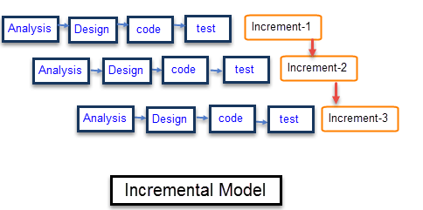

Iterative and Incremental software development is a method of software development that is modeled around gradual addition of features or functionalities after each successful version/iteration(technopedia.com). This model is also known as the Multiple Waterfall Model as it has the same phases as a waterfall model, only that it is repeated multiple times unlike the waterfall model which does not have repetitions. The model diagram above should give the general idea about the model which is to develop a system through repeated cycles in smaller portions of time which allows developers to take advantage of what was learned in the earlier versions of the system. Since there are small increments over time, it splits the whole process into smaller, more manageable chunks. The process does not try to implement all the requirements in one go. This allows a working version to be built quickly earlier in development while adding more features as it progresses.

While each Development Model has its own advantages and disadvantages, here we will only discuss its advantages as that is what led me to choose this model.

1. Its major advantage is that it generates a fully working software quickly and very early during the development.
2. It utilizes the principle of ‘divide and conquer’ for easier and more efficient development.
3. It is less prone to errors as each version is tested thoroughly and ensured that it contains no errors before release.
4. It is not a rigid model, and is flexible to changes.
5. It allows developers to utilize what they have learned while developing previous versions.
6. Clients can view and interact with each iteration and provide feedback for the next one.

Key Stages of development

Project Planning

During this stage, data that was required to develop the product was collected. Data was mostly collected by observing similar systems that were already functioning on the Internet. By visiting those sites and testing the features they had to offer, data on how these systems operated was obtained. An acquaintance who had past experience on these types of system also provided valuable pointers and information. Some minor details were added by speculation.

Project Design

The data and requirements that were gathered during the initial stage, was finally utilized in the design stage. Wireframes were made using online tools and provided a general idea of how the end product’s layout would look. A color scheme and overall User Interface was also put into consideration. After that, an Entity Relationship Diagram was made to show the inner design of the system.

Project Implementation

A prototype containing both the front end and back end was developed. Initially, it only contained a few basic functions and an unpolished front end. After multiple revisions, more features were added subsequently until the end product was developed.

Project Testing

Various tests were conducted to ensure that the end product was functioning optimally. White box testing, Black box testing and unit testing are some of the methods that were used to test the system. Actual end-users also tested the system’s capabilities and provided helpful feedback. Various scenarios were tested until finally, an error free system was produced.

Design Stage

Wireframe

Using Wireframe technology I have designed a basic layout of the site and its content. The image below is design of the homepage which features a top navigation bar that allows for quick access to other pages. Below that will be a section for image showcase and headings. After that, box models with an image, description and button will be featured. This type of box model will also be utilized in other pages.

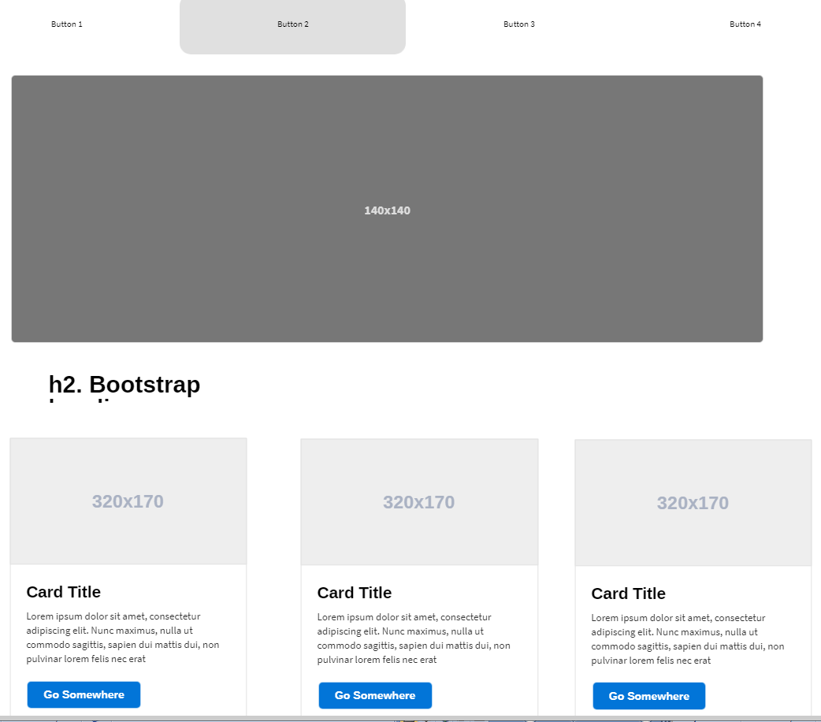

The Wireframe design below illustrates how the data regarding bookings will be shown in a tabular form. A clean table with various related info will be available to both the User and the Admin. There will be buttons along with the table that provide different functionality depending on whether it is accessed by the User or Admin.

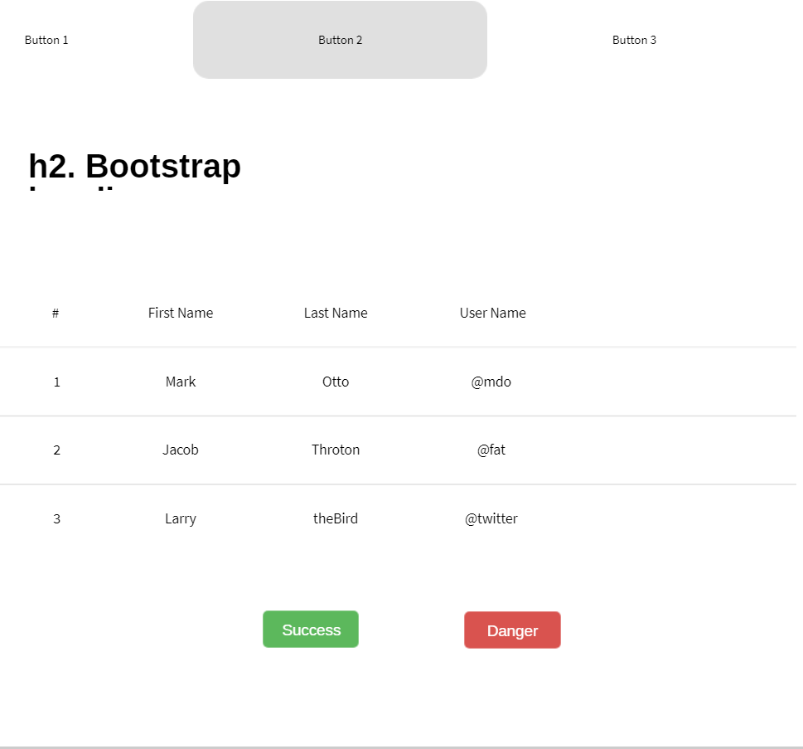

Entity Relationship Diagram

An Entity Relationship Diagram (ERD) is a structural diagram that shows the relationship between the entity sets stored in a database. It helps in visualizing the relations and the design of the database structure. ERDs are generally depicted in terms of the following models: <https://searchdatamanagement.techtarget.com/definition/entity-relationship-diagram-ERD>

A conceptual data model that provides an overview of the project scope and the relation between data sets. But, it is lacking in specific detail.

A logical data model which contains more details compared to a conceptual data model and has specific attributes and relationships among data points

A physical data model, that provides a blue print for the implementation for the database of a logical data model.

An ERD has three main components that are:

1. Entities: which are objects or concepts that can have data stored about them.
2. Attributes: which are the properties or characteristics an entity may possess.
3. The relationship between different entities.

(searchdatamanagement, 2018)

The ERD of my project is built around seven main entities. It was created using QSEE Superlite software.

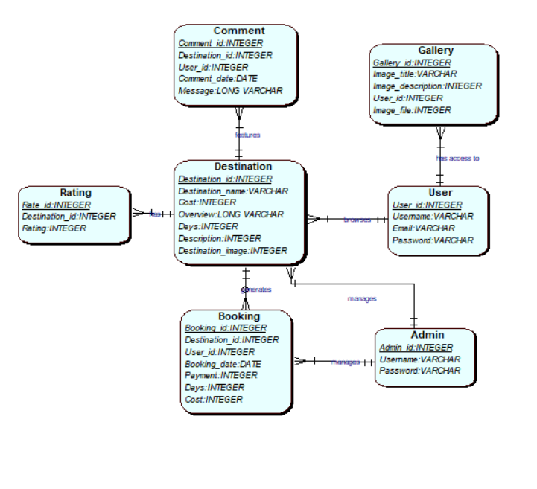

1. Destination
2. Booking
3. Rating
4. Comment
5. Gallery
6. User and
7. Admin

Destination is major entity that is being focused here as it is linked to Comment, Rating and Booking. The Admin manages the destinations, which is then viewed by the User.

The Logical design of the ERD is as follows:

1. Destination (*Destination_id*, Destination_name, Cost, Overview, Days, Description, Destination_image)
2. Booking (*Booking_id*, *Destination_id*, *User_id*, Booking_date, Payment, Days, Cost)
3. Rating (*Rate_id*, *Destination_id*, Rating)
4. Comment ( *Comment_id*, *Destination_id*, *User_id*, Comment_date, Message)
5. Gallery (*Gallery_id*, Image_title, Image_description, *User_id*, Image_file)
6. User (*User_id*, Username, Email, Password)
7. Admin (*Admin_id*, Username, Password)

Use Case Diagram

A use case diagram is a graphic representation of the possible interactions among the elements of a system. Following use case diagram represents the interactions of the user. It was also designed using the QSEE Superlite software.

User Interface

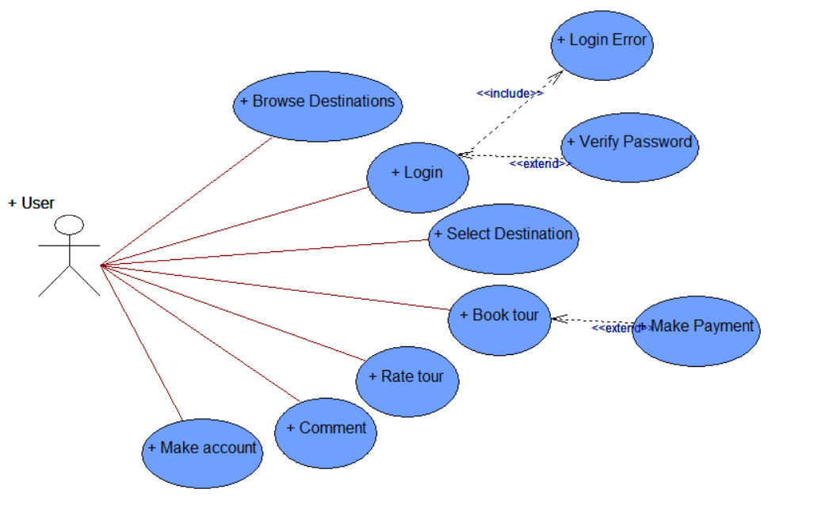

User is the single actor in this interface. There are seven use cases through which the actor can interact with the system. The first one is Browse Destinations which can be done with or without logging in. Next is Login which the User needs to verify in order to pass this case else an error will be displayed. Next is the select destination followed by the book tour on which a payment can also be made. Following that are rate tour and comment which are additional features.

Admin Interface

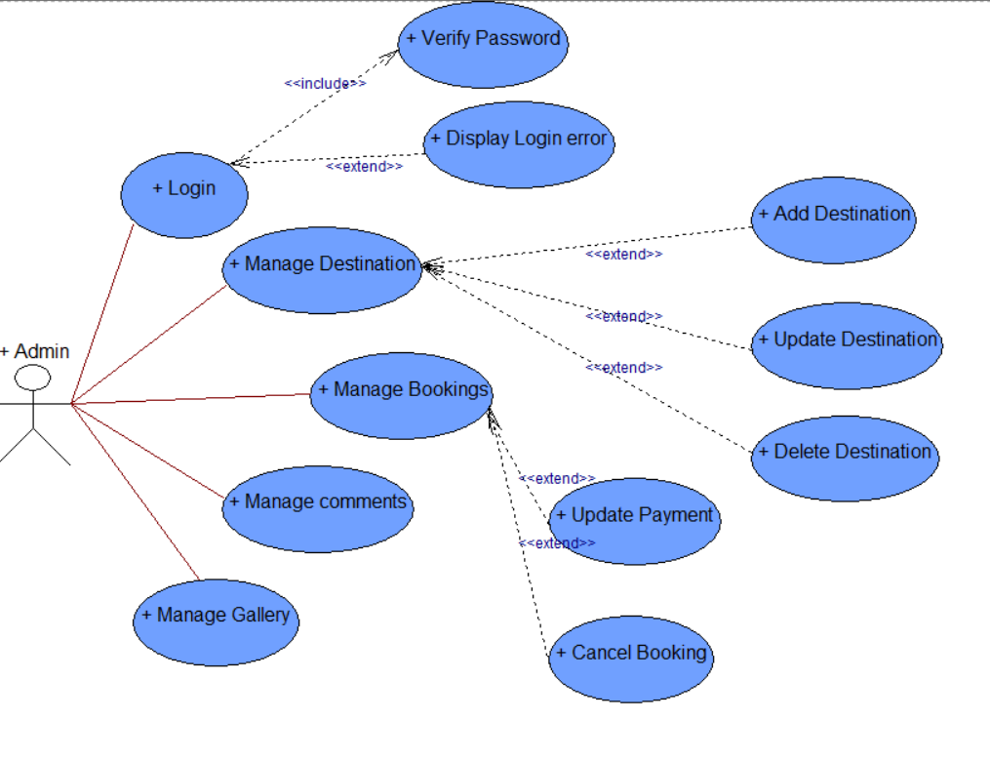

Here the Admin is the actor who can interact with system by logging in like in the User Interface. The Admin has the authority to manage destinations and can easily delete or update existing destination and also add new ones. The next use case is the manage bookings which allows the Admin to manage the booking made by the Users. Following that are the manage comments and manage gallery cases.

Creation of MySQL Tables

Using the Entity Relationship Diagram I have created seven database tables in MySQL.

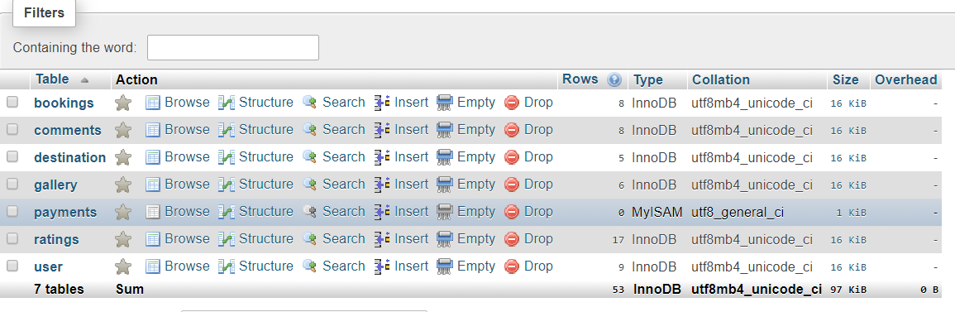

The first table is the User table with id as the primary key in the table. It holds the username, email and password values of the user. It also stores the image filename for the users’ profile image which defaults to a certain image if it is not selected. Finally, the level field holds the value for the type of user that is logging in. A regular has the level of 0 which is by default. An admin however has the value of 1 differentiating it from the regular users.

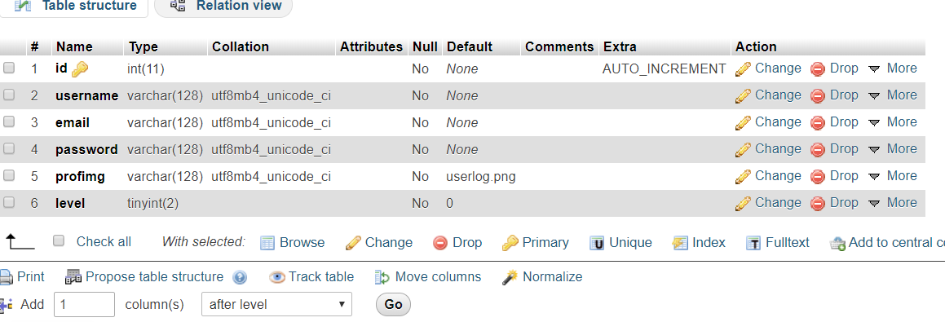

The next table is the destination table which uses destid as the primary key. It holds various data about a destination such as the name, days, a brief overview and lengthy description. It also features two different values for days and cost. This is for the package options that the user can choose from.

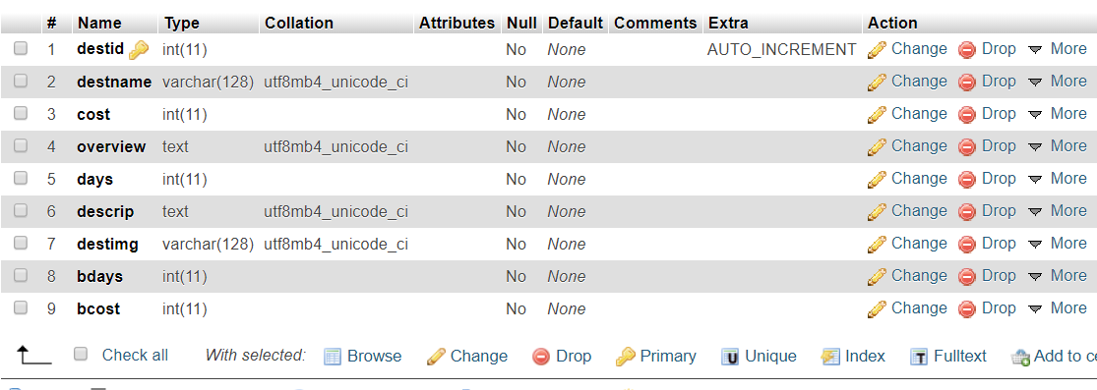

The following table shows the booking table and its attributes. It uses an id as the primary key and also utilizes the destination id and user id to store specific values. It holds the date and payment information as well as the day and cost value. Data is entered in this table after a user books a tour for certain destination.

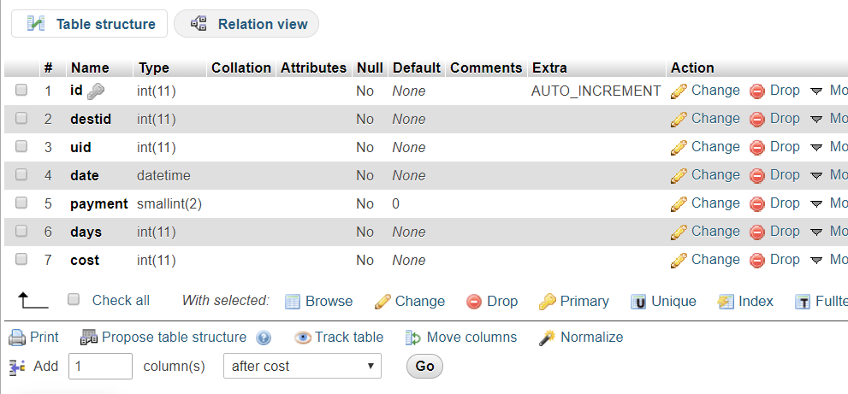

The comment table holds the data for comments for a particular destination. It uses cid as the primary key while user id is used an identifier of who made the comment. It also holds the date and message values.

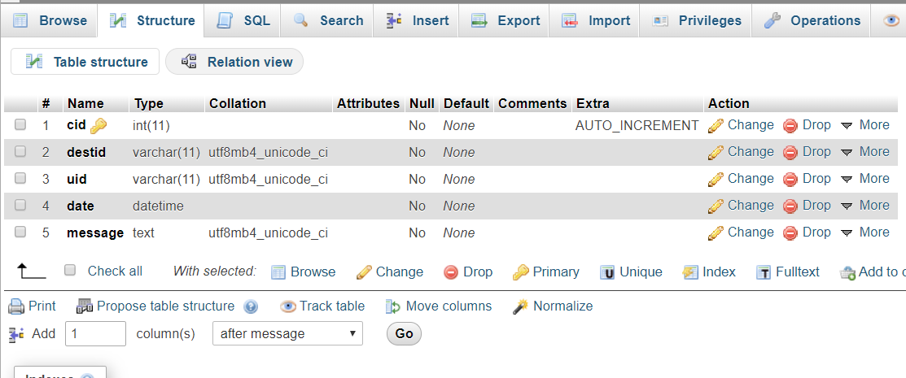

Front end snippets

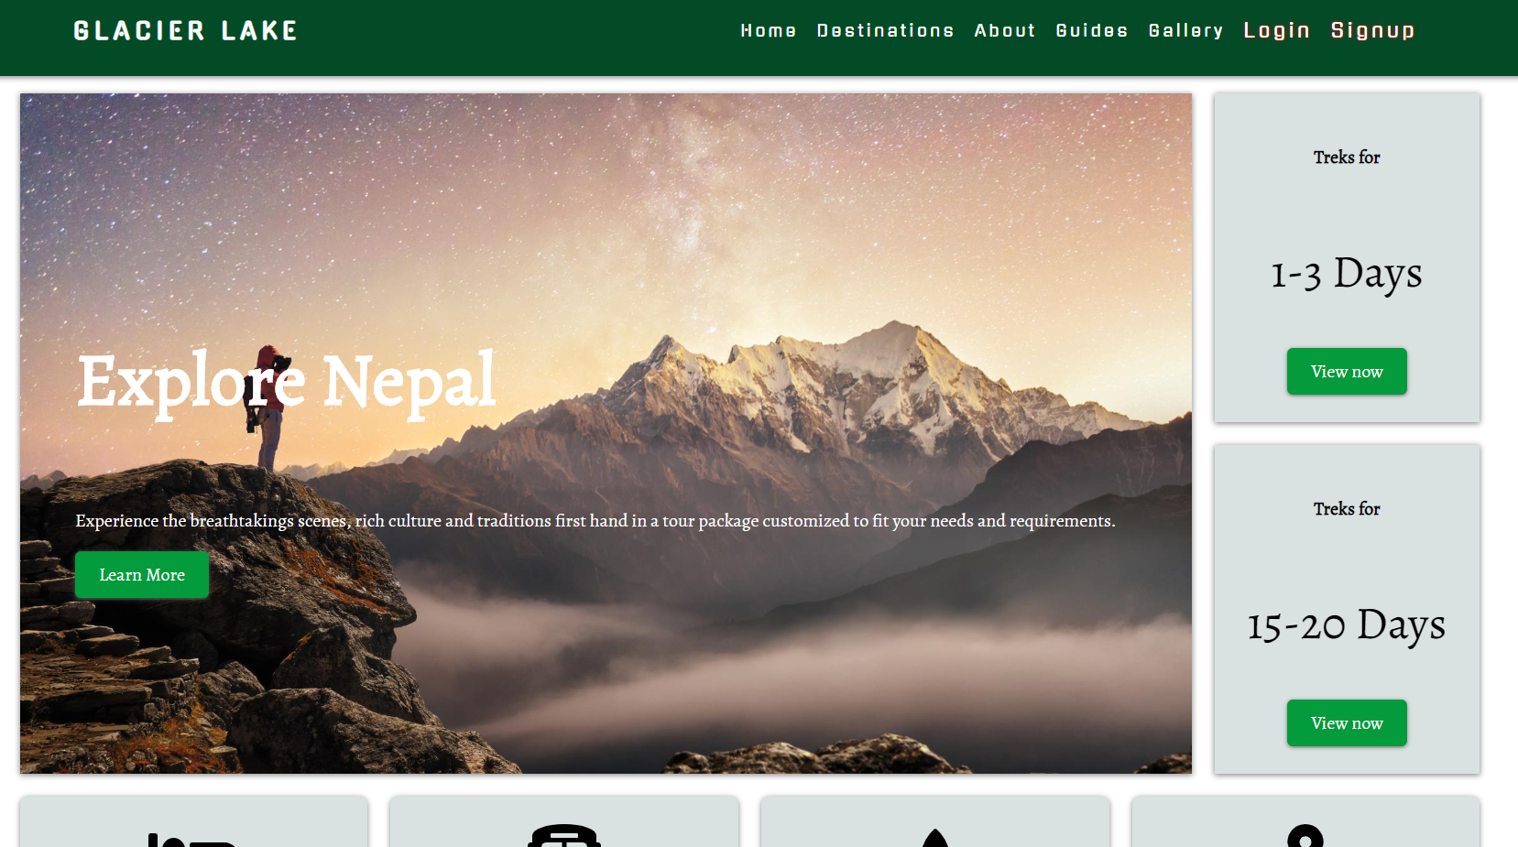

This is the home page of Glacier Lake. It follows the design that was made using wireframe. It was developed using HTML5, CSS3, JavaScript/jQuery and PHP. I have not used any type of framework and have my own CSS implemented as I found it much easier to work in this manner.

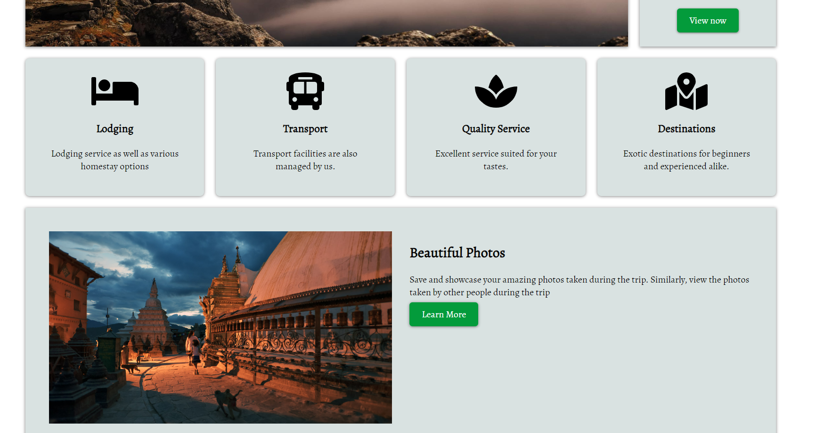

I have also designed my site to be fully responsive and can be viewed on multiple screen sizes. The screenshots below demonstrate my point.

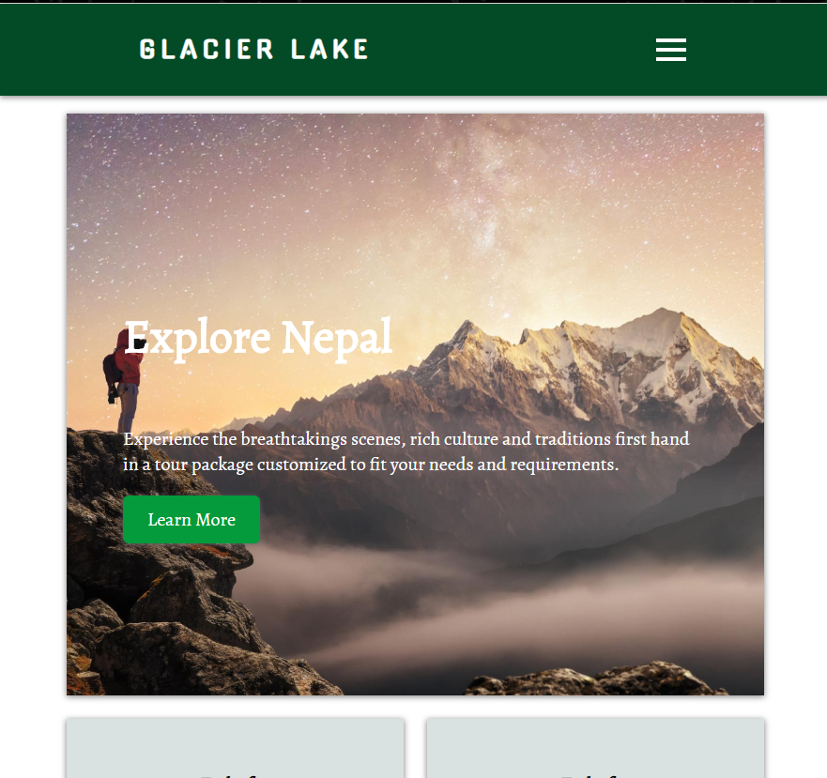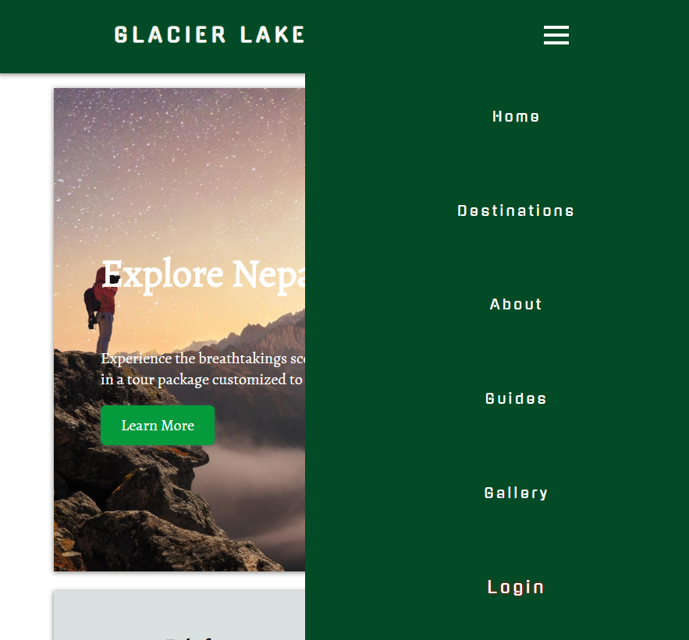

The following snippet shows the code used to develop the home page. It also shows that I have used online scripts or CDNs such as Google Fonts and Font Awesome for various fonts and icons in the site. A Content Delivery Network (CDN) is a system of distributed servers that delivers web content to a user based on certain criteria.

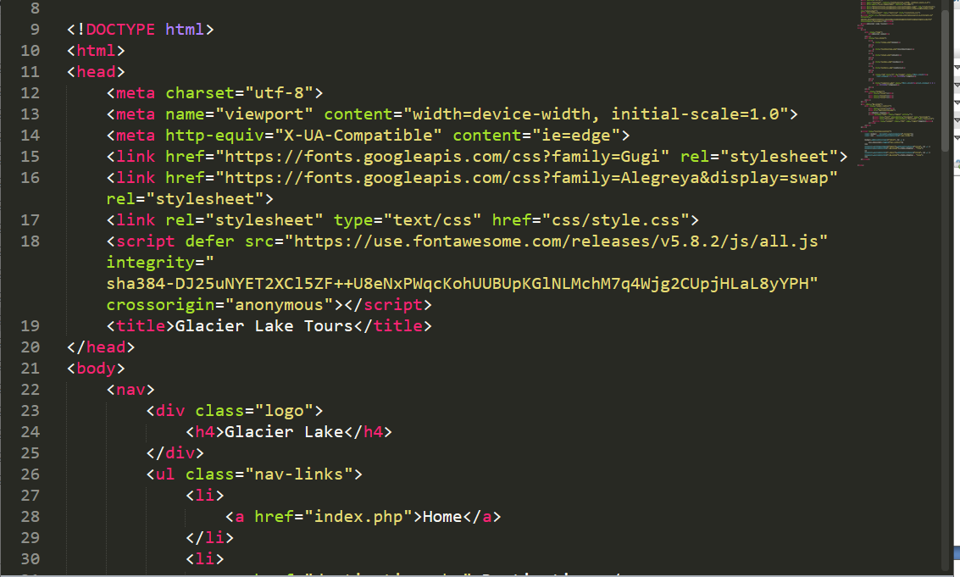

I have also used the following JavaScript for the different actions and behaviors.

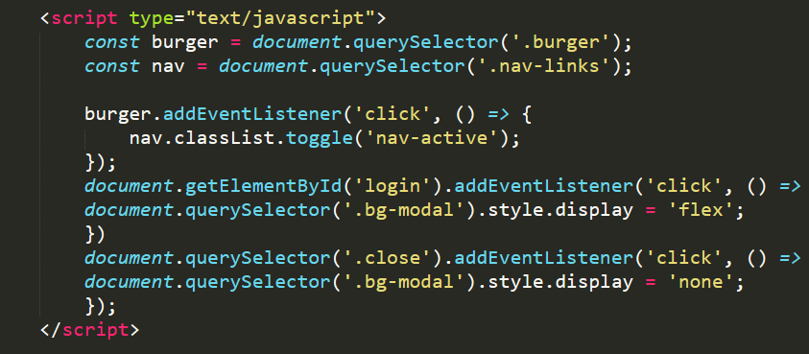

One of its functions is the popup modal that opens when the login button is clicked:

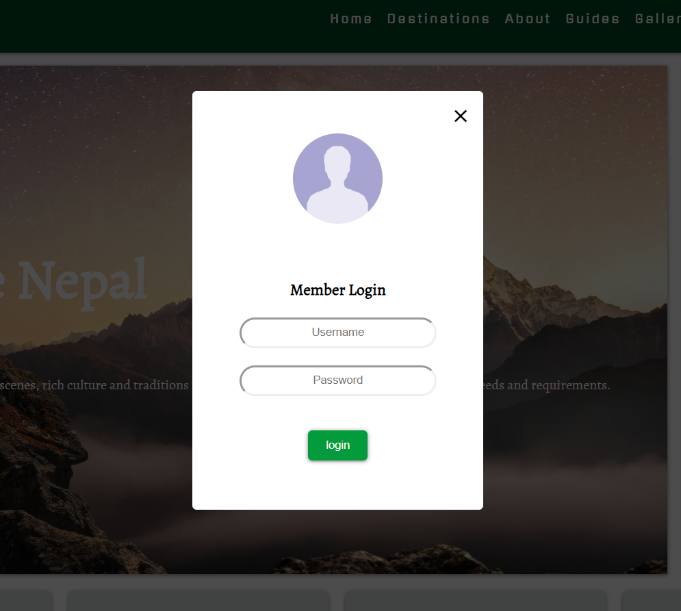

Back end snippets

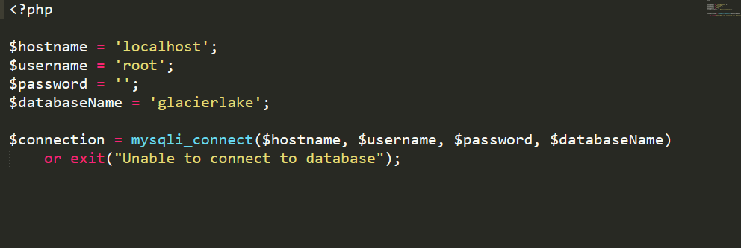

This is the connection PHP code that connects the website to database so that it is dynamic in nature. The hostname is set to localhost as I have used XAMPP software as the local server environment for developing my product. The username and password values are the default values for this environment, while name of the database is ‘glacierlake’.

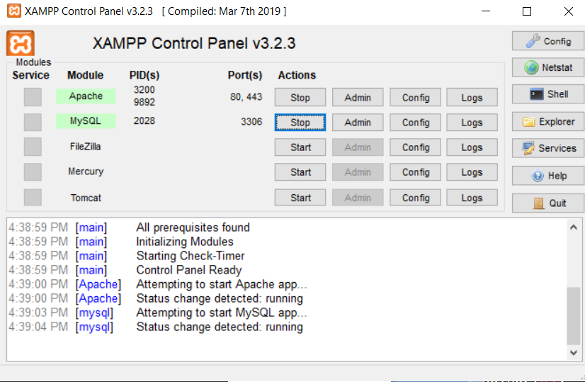

The following snippet shows the bookings section in the admin panel after the admin has logged in to the website. The overall theme stays the same while additional features are granted to the Admin. It lists all the bookings made by users along with the destination name, username, date, days as well as payment information. The admin also has the authority to cancel or accept payment of a particular booking.

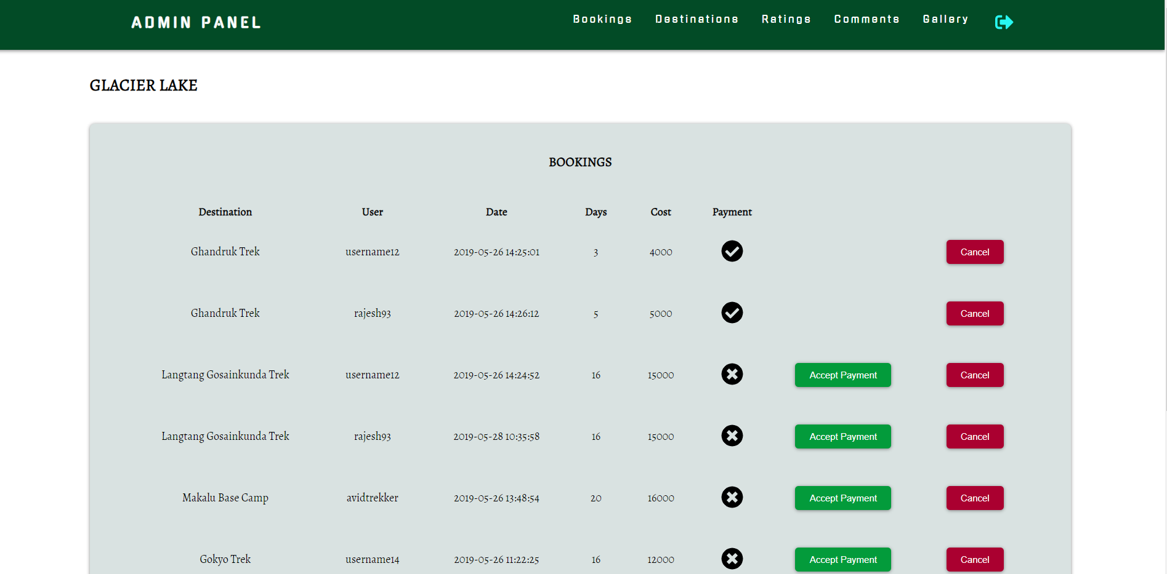

Snippets of code used in the Admin panel.

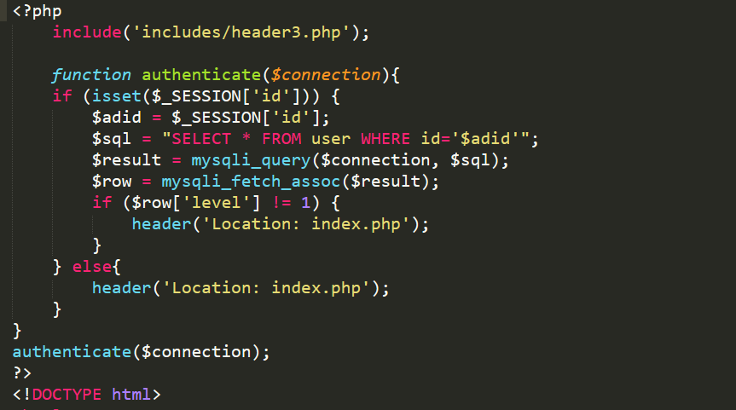

The above code authenticates if the user really is an admin and prevents access from other users. While code below displays the booking information.

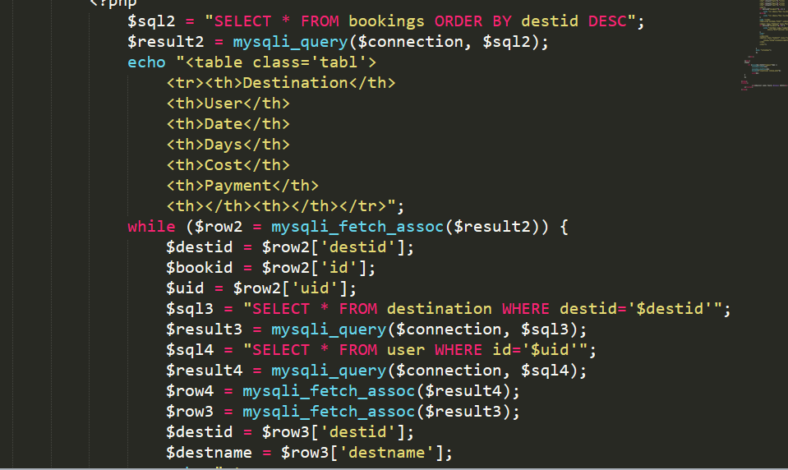

The following snippet shows the destination section that admin can access. As you can see the admin can edit or delete the existing destination or add a new one altogether.

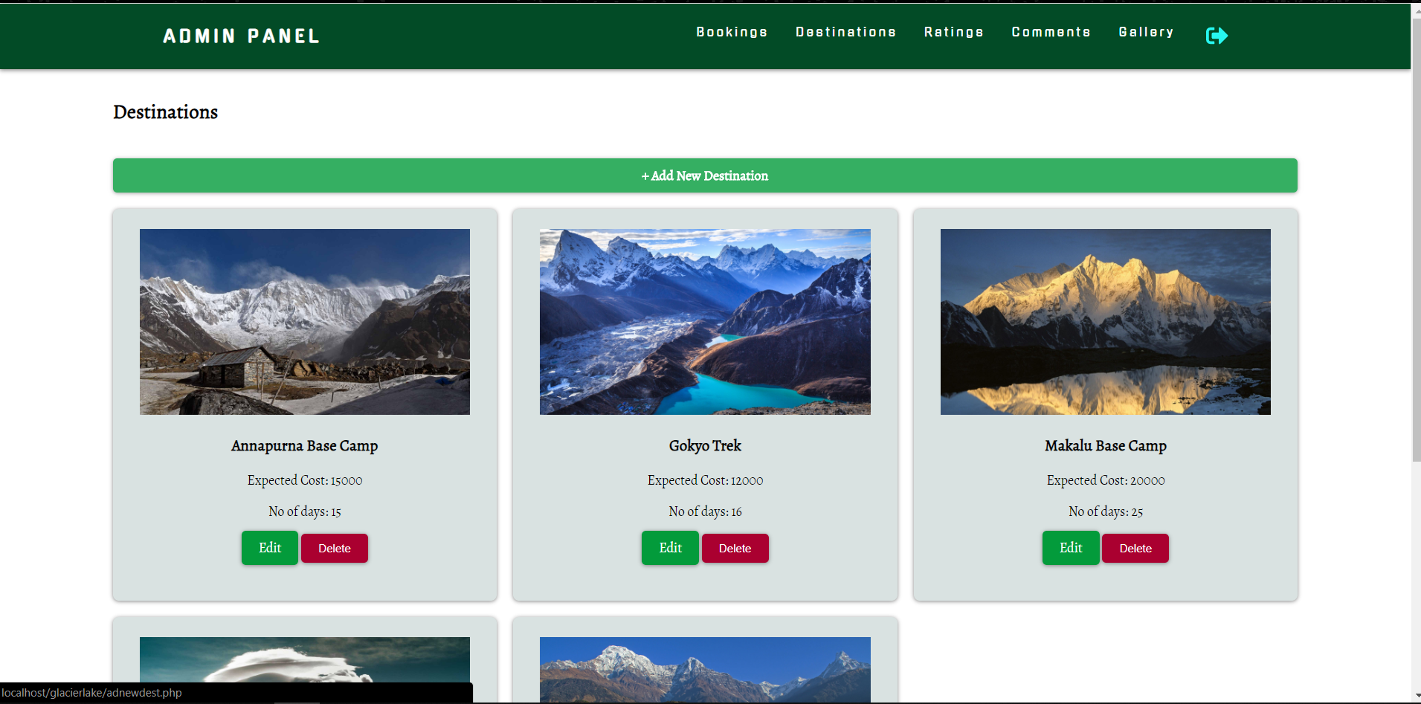

Snippet of the code used in creating the destination section:

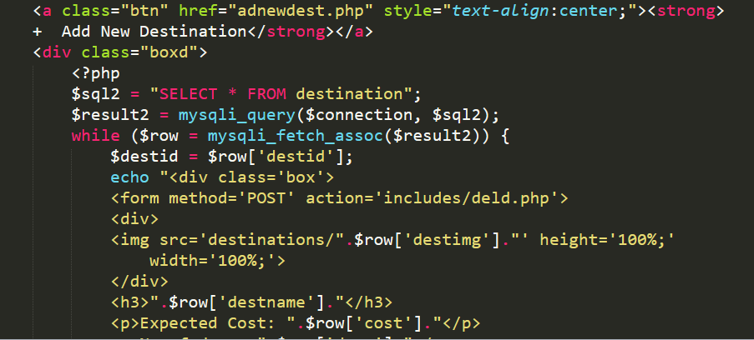

The various actions that the Admin can perform are made possible using a number of functions inside includes folder. These functions are executed when a certain button is pressed or action is performed, which then returns a result.

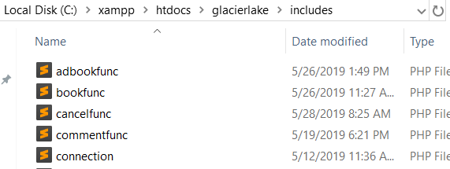

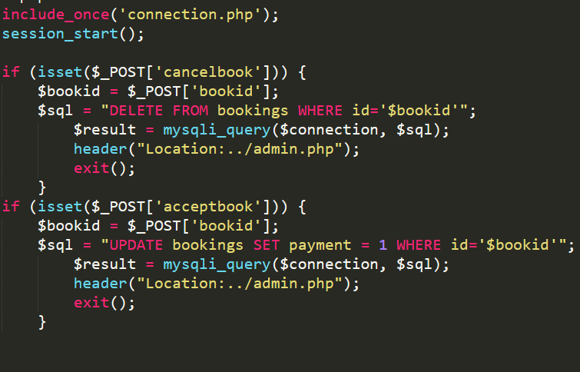

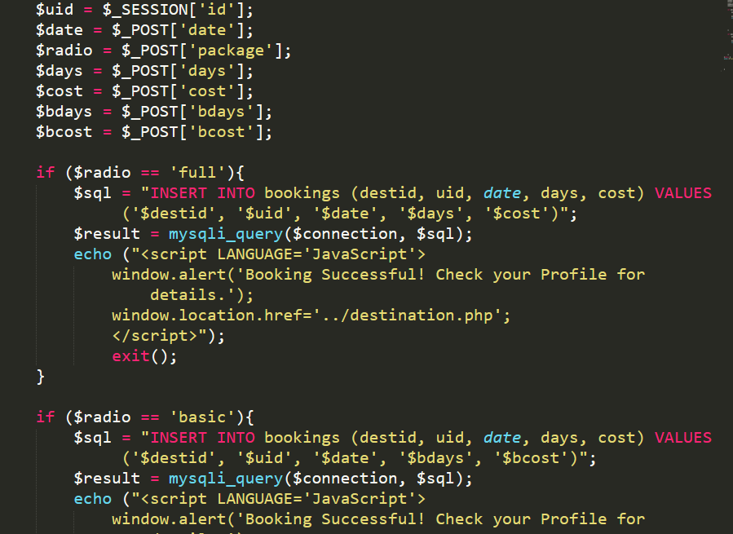

Testing

Register

The following image shows the register page to register as user of the system. The first field is the username field which must be unique as only no two users can have the same username. The next field is email field which like the username must also be unique. The next two fields are the password and verify password fields which must match for verification.

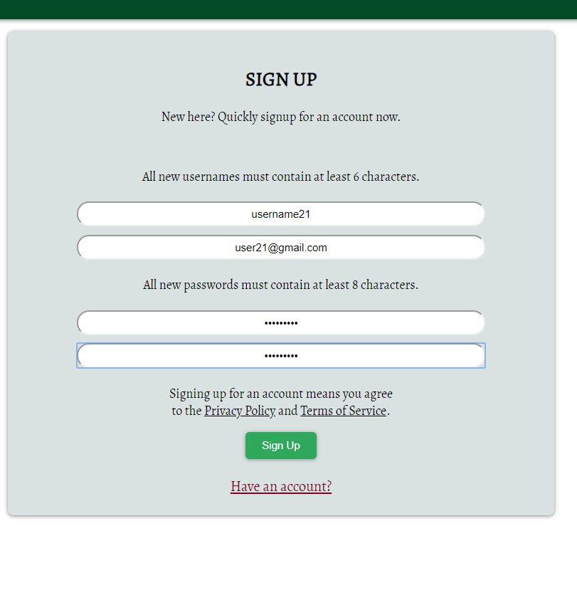

After the Signup button is clicked, the data is checked for any errors and after successful verification, enters the user data in the database. This yields the following message:

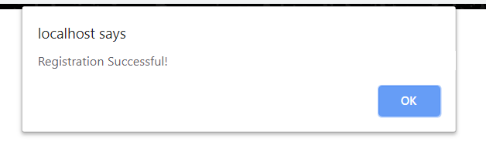

Now, to test the login feature, we will try to login using the same credentials that we registered in the previous step. After the login button is clicked, the username and password are checked using server-side validation.

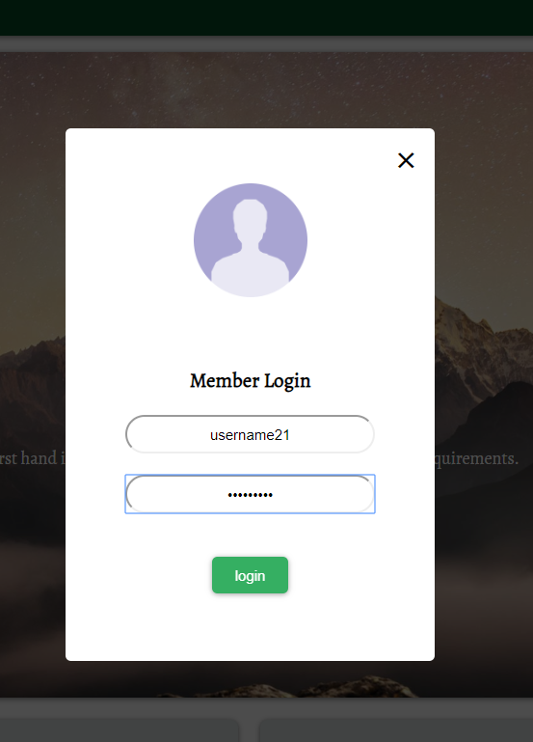

It seems that an incorrect password was entered for this user account. Checking with database has returned an error, which has led to the following prompt:

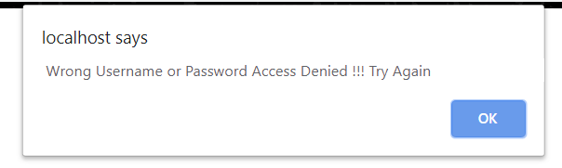

In the second try we have successfully logged in and the snippet below shows the user profile that has created.

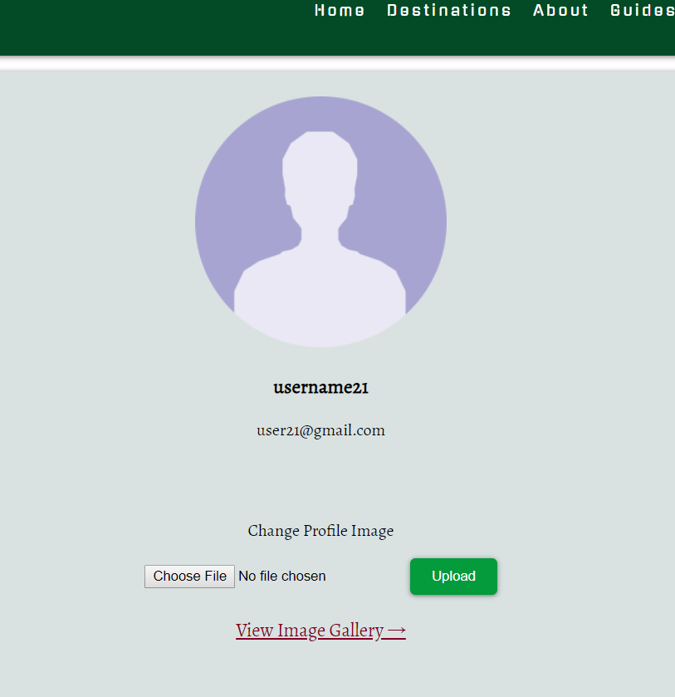

After logging in we will go to any random destination available to us and try to book a tour.

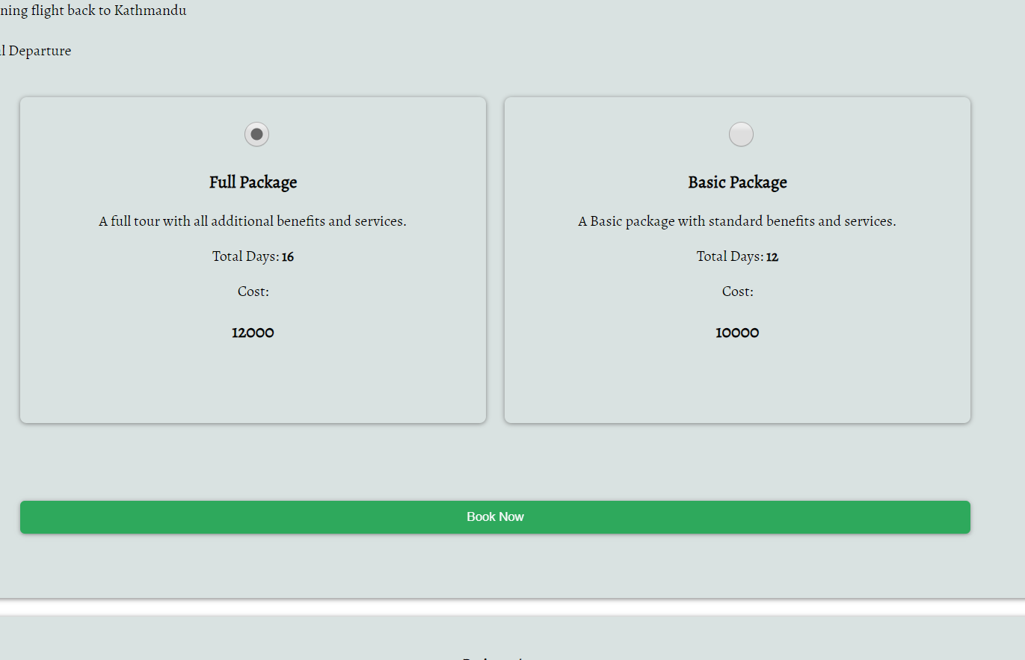

There are two package choices here, and we have decided to choose the Full Package over the basic one. Upon clicking the Book Now button, it should record the destination and package details as well as our user details and store it in the database.

The following message shows that our booking was successful:

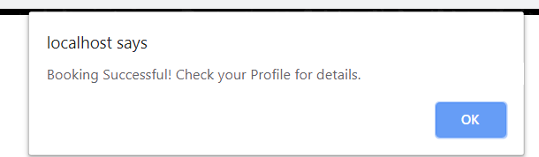

Checking the profile section we get the details of our booking as well as the options to cancel it or make the payment.

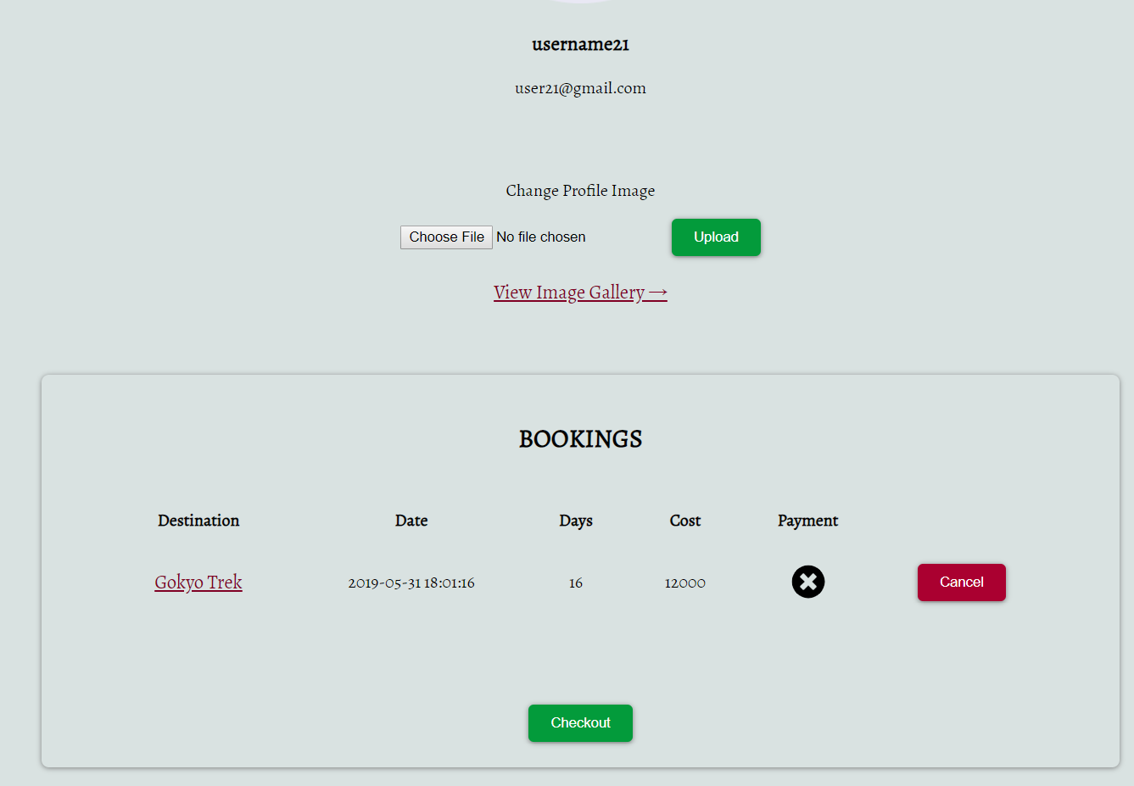

A destination page not only lists the details, cost and package options but also the feature to rate and comment on a particular destination as user feedback. This serves as some reference for other users as well.

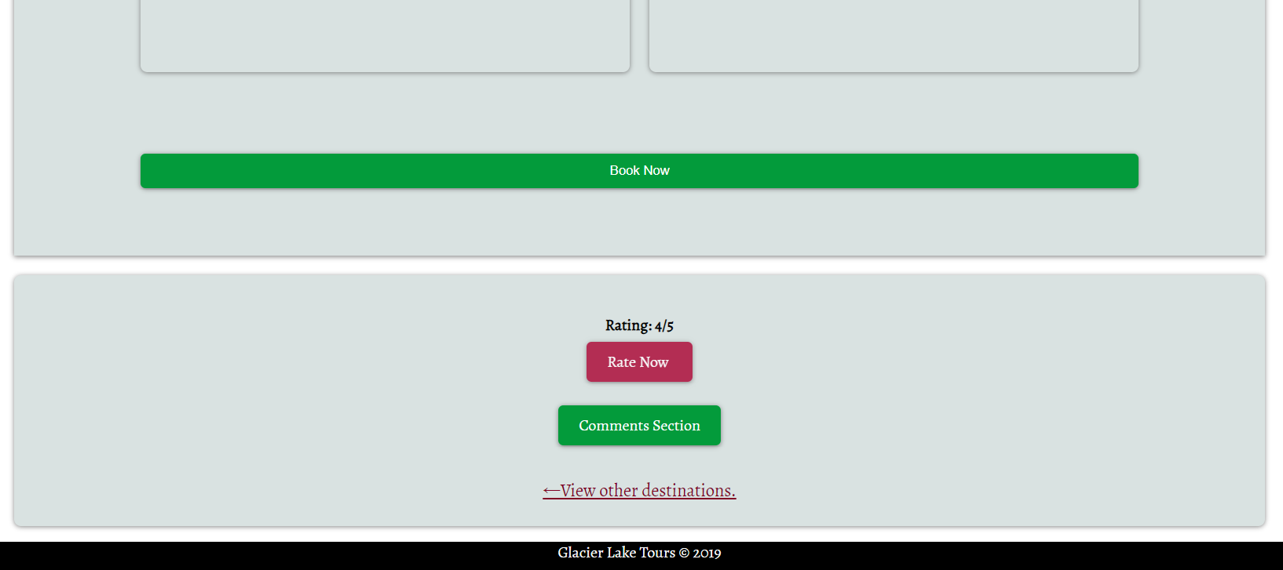

Now, to test the rating feature we have proceeded to the ratings page which features this interactive method to rate the destination:

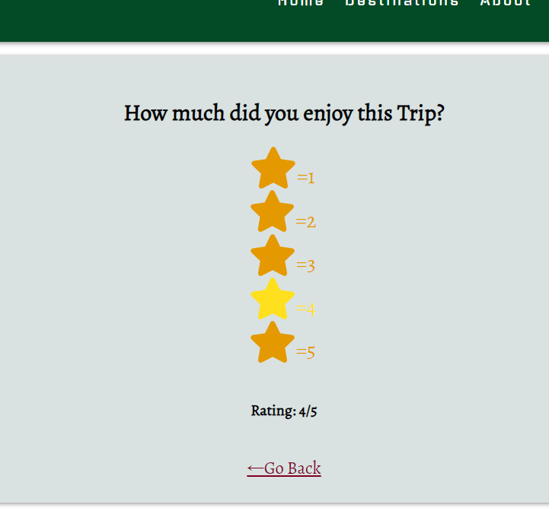

After successfully rating we get the following message:

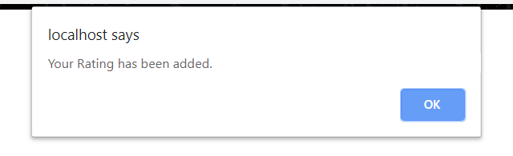

After that, we will test the comment feature. Here in the comments page, it lists all the comments users have made on that particular destination as well as the ability to comment as well:

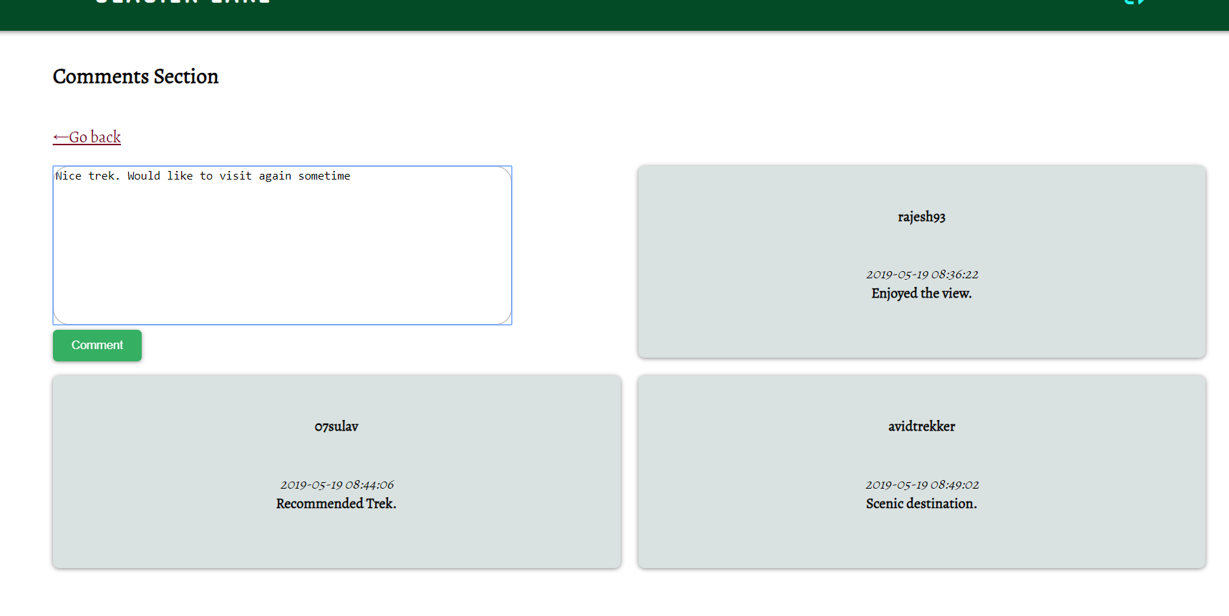

Writing a comment and clicking on post, we can see that our comment has been added to the comment section. There also exists an option to delete the comment we have made.

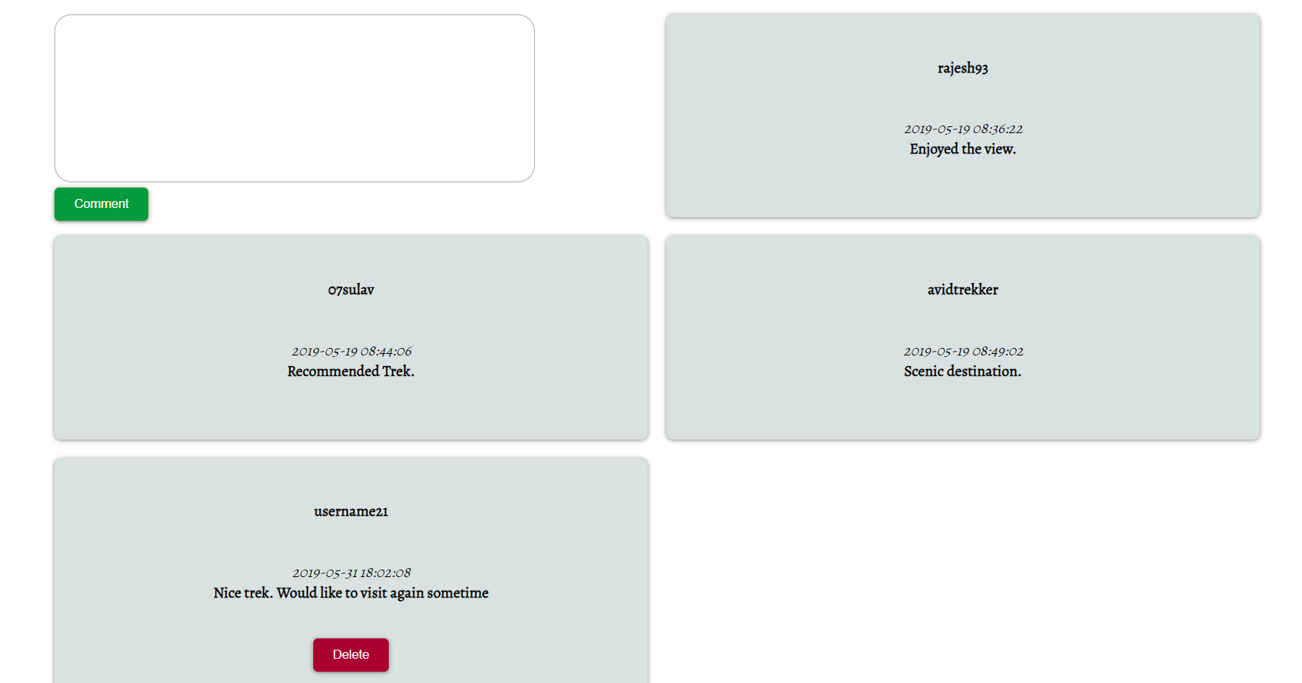

Product Evaluation

The end product – Glacier Lake was developed with one purpose in mind i.e. to help user travel. This was achieved using Iterative and Incremental software development model along with various tools and technologies such HTML, CSS, JavaScript, PHP, MySQL etc. The product requirements and objectives were always kept in mind while designing and developing the website. The product requirements as per the Intial Specifications were: (using MoSCoW prioritization)

|  |  |  |
| --- | --- | --- |
| S.NO | Requirement Description | MoSCoW |
| 1 | Users can browse the site without registering. | M |
| 2 | Users can register an account by signing up. | M |
| 3 | Users can search destinations. | M |
| 4 | Registered users can view their profile and edit it. | M |
| 5 | Registered users can add photos to their profile. | M |
| 6 | Registered users can rate and comment on a travel site. | M |
| 7 | Registered users can book a tour online. | S |
| 8 | Admin panel for managing the site and destinations | M |
| 9 | Admin can add, delete or update destinations. | M |
| 10 | Admin can monitor suspicious activity. | S |
| 11 | Fully responsive site with support for mobile viewing | M |
| 12 | PayPal integration for online payment. | S |
| 13 | Mobile app with support for Android | C |

It would be safe to say that most if not all the requirements have been fulfilled and the final product is up to mark. However, no product is truly perfect as there is always room for more improvement. There are certain features that would have been better if it were more advanced and better implemented. All in all, I would say that the developed product is adequate for the requirements given.

As the developer is invested in developing the product, he/she would certainly say the product developed is of satisfactory quality. However, it is not for them to decide as it is the end-user who has the final say in the matter. For this, an acquaintance of mine was selected to be the end-user in this scenario. While, he was not from an IT background, he had basic computer knowledge required to use the system. He was also already familiar with Online Booking System and had used multiple such systems as part of his work. While he did not know the exact terms used to describe certain features, he had a general idea of how things should work and what features a system should have.

After completing the system evaluation process, he gave me following feedback:

1. The overall User Interface was found to be adequate and simple enough for everyone to use. Additional features were suggested to be added.
2. A confirmation email was needed when a new member registered and also before checkout. An email with a confirmation link would make the system more secure.
3. A new feature needed to be integrated to allow user to create their own custom package with their preferred destinations and number of days. After creation, price of the package should also be listed there.
4. There was no feature to let the system or Admin know if the user had finished the tour. Due to this problem the booking data would remain in the database until the Admin removed it themselves.
5. The gallery are had no criteria for the order in which the images were displayed. The images were just displayed randomly. A feature needed to be integrated that allowed users to vote or like images and the most liked images would show on top.

Project Evaluation

In my own understanding, I would say that my project Online Tour Guidance System was a success overall. It is by no means an exceptional project, but as a first I feel that it is adequate. Most if not all the requirements have been met and system implemented in the product also works fine. I had some issues in the beginning while managing this project, but in the end things worked out well. I utilized some of the project management techniques that I had knowledge of and previously used.

A Gantt chart was used to schedule and categorize the tasks that I had to carry out. A Gantt chart is a type of bar chart that visualizes the overall project schedule. The tasks to be performed are along the vertical axis while the time intervals along the horizontal axis as can be seen below:

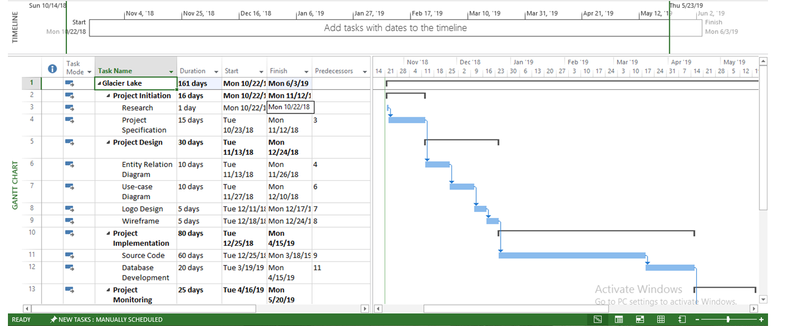

Project Planning

During this stage, data that was required to develop the product was collected. Data was mostly collected by observing similar systems that were already functioning on the Internet. By visiting those sites and testing the features they had to offer, data on how these systems operated was obtained. An acquaintance who had past experience on these types of system also provided valuable pointers and information. Some minor details were added by speculation.

Project Design

The data and requirements that were gathered during the initial stage, was finally utilized in the design stage. Wireframes were made using online tools and provided a general idea of how the end product’s layout would look. A color scheme and overall User Interface was also put into consideration. After that, an Entity Relationship Diagram was made to show the inner design of the system.

Project Implementation

A prototype containing both the front end and back end was developed. Initially, it only contained a few basic functions and an unpolished front end. After multiple revisions, more features were added subsequently until the end product was developed.

Project Testing

Various tests were conducted to ensure that the end product was functioning optimally. White box testing, Black box testing and unit testing are some of the methods that were used to test the system. Actual end-users also tested the system’s capabilities and provided helpful feedback. Various scenarios were tested until finally, an error free system was produced.

A few setbacks interfered with smooth development of the product but those were mostly due to personal issues rather than technical ones. I found myself to be lacking in time management and focus in some parts of the development process. But overall the project was developed without much issue.

Future Enhancement

Glacier Lake despite having a few shortcomings is a complete system in and of itself. I have tried my best ensure that it has been designed and developed to meet all the necessary requirements. It has all the crucial features a travel site could require to work properly. Despite all that there is more than enough room for improvement. No project is truly complete as additional features and upgrades can be added to improve it. There may be some concept or idea of feature we may wish to add but lack the necessary skills to do. While other features or upgrades may only be apparent to us once we have learnt something new.

One of the upgrades the next version could include is the ability for users to create their own custom package according to their needs and preferences. Having only two options to choose for a tour package makes it limited for the user. By adding the option to customize a tour by adding or removing certain destinations and by increasing or decreasing the number of days makes site broader and more scalable.

Another feature to be added could be advertisement sections. Advertisements are really popular on the internet these days. Advertisements also help to generate revenue. A few (emphasis on few) advertisement sections with related ads could boost the website.

The feature to inform the system and admin after a particular tour has ended would be very helpful to the system. Currently there is no way for the system to know when a tour has ended. As such a tour that has ended several months ago would still be shown on the booking list of the Admin unless it is removed manually. An automated system implementing this feature would be very beneficial.

Other minor enhancements could be improving the design and overall User Interface and the integration of map functionalities.

Conclusion

Online Tour Guidance System was a part of the Production Project module and also the final year project. It is the culmination of the past four years of climbing the academic ladder. It would be no understatement to say that it was the biggest and the most resource-intensive project that I have completed till date. With that being said, I have learnt a lot and gained much experience as I developed this project. This report evidences the research that I have conducted as well as the work that I have done.

To summarize this entire project and my research and findings in to a few words:

This web app (Glacier Lake) which utilizes the online booking system and helps users travel provides a solution to utilize the enormous potential that is online tourism.

Bibliography

Bogdanovych A., Berger H., Simoff S., Sierra C. (2006) Travel Agents vs. Online Booking: Tackling the Shortcomings of Nowadays Online Tourism Portals. In: Hitz M., Sigala M., Murphy J. (eds) Information and Communication Technologies in Tourism 2006. Springer, Vienna

Collins, J. (2001). *The Basics of Web Technologies*. [online] Alphadevx.com. Available at: http://www.alphadevx.com/a/7-The-Basics-of-Web-Technologies

SearchDataManagement. (2018). *What is entity relationship diagram (ERD)? - Definition from WhatIs.com*. [online] Available at: <https://searchdatamanagement.techtarget.com/definition/entity-relationship-diagram-ERD>

Techopedia.com. (2019). *What is Iterative and Incremental Development? - Definition from Techopedia*. [online] Available at: <https://www.techopedia.com/definition/25895/iterative-and-incremental-development>

Whatisdbms.com. (2016). *Different Types of Database Users in DBMS*. [online] Available at: <https://whatisdbms.com/different-types-of-database-users-in-dbms/>

Appendices

Appendix A

Evidence of design documents



Appendix B

Meeting Sheet

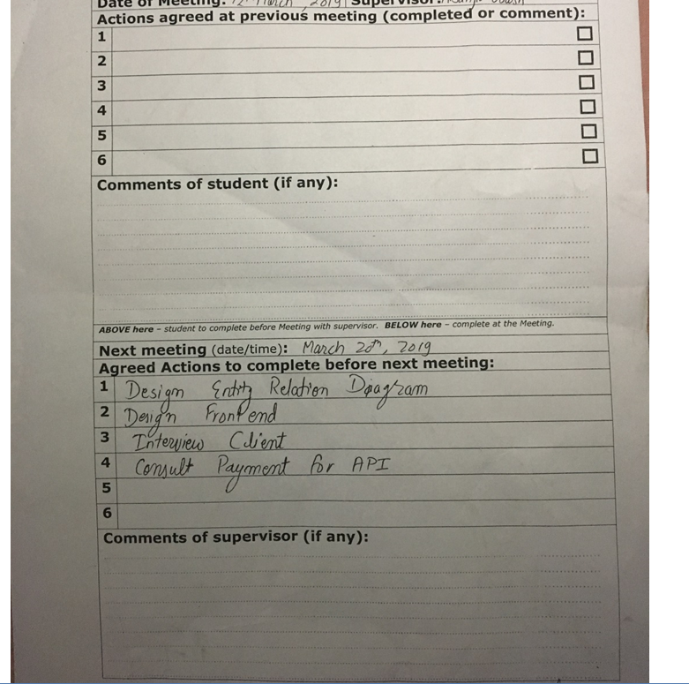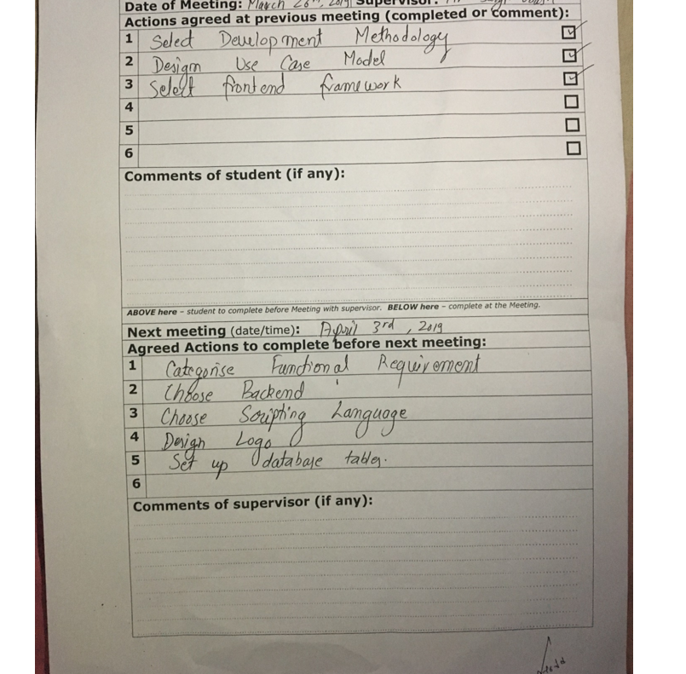

Appendix C

Code reference

Index.php

<?php

include_once('includes/connection.php');

include('includes/headfunc.php');

session_start();

if (isset($_SESSION['id'])) {

head2($connection);

} else {

head1($connection);

}

?>

<body>

<div class="wrapper">

<!--TOP -->

<section class="top-container">

<header class="showcase">

<h1>Explore Nepal</h1>

<p>Experience the breathtakings scenes, rich culture and traditions first hand in a tour package customized to fit your needs and requirements.</p>

<a href="destination.php" class="btn">Learn More</a>

</header>

<div class="top-box top-box-a">

<h4>Treks for</h4>

<p class="price">1-3 Days</p>

<a href="destination.php" class="btn">View now</a>

</div>

<div class="top-box top-box-b">

<h4>Treks for</h4>

<p class="price">15-20 Days</p>

<a href="destination.php" class="btn">View now</a>

</div>

</section>

<!--box-->

<section class="boxes">

<div class="box">

<i class="fas fa-bed fa-4x"></i>

<h3>Lodging</h3>

<p>Lodging service as well as various homestay options</p>

</div>

<div class="box">

<i class="fas fa-bus-alt fa-4x"></i>

<h3>Transport</h3>

<p>Transport facilities are also managed by us.</p>

</div>

<div class="box">

<i class="fas fa-spa fa-4x"></i>

<h3>Quality Service</h3>

<p>Excellent service suited for your tastes.</p>

</div>

<div class="box">

<i class="fas fa-map-marked-alt fa-4x"></i>

<h3>Destinations</h3>

<p>Exotic destinations for beginners and experienced alike.</p>

</div>

</section>

<section class="info">

<img src="img/slide2.jpg" alt="">

<div>

<h2>Beautiful Photos</h2>

<p>Save and showcase your amazing photos taken during the trip. Similarly, view the photos taken by other people during the trip</p>

<a href="gallery.php" class="btn">Learn More</a>

</div>

</section>

</div>

<footer>

<p>Glacier Lake Tours &copy; 2019</p>

</footer>

</body>

</html>

<?php

include_once('includes/connection.php');

include('includes/headfunc.php');

session_start();

if (isset($_SESSION['id'])) {

head2($connection);

} else {

head1($connection);

}

?>

<body>

<div class="wrapper">

<!--TOP -->

<section class="top-container">

<header class="showcase">

<h1>Explore Nepal</h1>

<p>Experience the breathtakings scenes, rich culture and traditions first hand in a tour package customized to fit your needs and requirements.</p>

<a href="destination.php" class="btn">Learn More</a>

</header>

<div class="top-box top-box-a">

<h4>Treks for</h4>

<p class="price">1-3 Days</p>

<a href="destination.php" class="btn">View now</a>

</div>

<div class="top-box top-box-b">

<h4>Treks for</h4>

<p class="price">15-20 Days</p>

<a href="destination.php" class="btn">View now</a>

</div>

</section>

<!--box-->

<section class="boxes">

<div class="box">

<i class="fas fa-bed fa-4x"></i>

<h3>Lodging</h3>

<p>Lodging service as well as various homestay options</p>

</div>

<div class="box">

<i class="fas fa-bus-alt fa-4x"></i>

<h3>Transport</h3>

<p>Transport facilities are also managed by us.</p>

</div>

<div class="box">

<i class="fas fa-spa fa-4x"></i>

<h3>Quality Service</h3>

<p>Excellent service suited for your tastes.</p>

</div>

<div class="box">

<i class="fas fa-map-marked-alt fa-4x"></i>

<h3>Destinations</h3>

<p>Exotic destinations for beginners and experienced alike.</p>

</div>

</section>

<section class="info">

<img src="img/slide2.jpg" alt="">

<div>

<h2>Beautiful Photos</h2>

<p>Save and showcase your amazing photos taken during the trip. Similarly, view the photos taken by other people during the trip</p>

<a href="gallery.php" class="btn">Learn More</a>

</div>

</section>

</div>

<footer>

<p>Glacier Lake Tours &copy; 2019</p>

</footer>

</body>

</html>

Style.css

{

margin: 0px;

padding: 0px;

box-sizing: border-box;

}

body{

display: block;;

background: white;

margin: 1px !important;

font-family: 'Alegreya', serif;

}

nav{

display: flex;

justify-content: space-around;

align-items: center;

min-height: 7vh;

background-color:#024b26;

font-family: 'Gugi', cursive;

box-shadow: 0 1px 5px rgba(104, 104, 104, 0.8);

margin-bottom: 15px;

}

.logo{

color: white;

text-transform: uppercase;

letter-spacing: 5px;

font-size:20px;

}

.nav-links{

display: flex;

justify-content: space-around;

width: 40%;

}

.nav-links li{

list-style: none;

}

.nav-links a{

color: white;

text-decoration: none;

letter-spacing: 3px;

font-size: 14px;

}

.nav-links a:hover{

color:#e5a9a9;

font-size: 16px;

text-decoration: underline;

}

.norml{

text-decoration: underline;

font-size: 18px;

color:#800024;

}

.norml:hover{

cursor: pointer;

text-shadow: 2px 2px 16px #aa0030;

}

.burger{

display: none;

cursor: pointer;

}

input[type=radio] {

border: 0px;

width: 100%;

height: 2em;

}

.burger div{

width: 25px;

height: 3px;

background-color: white;

margin: 5px;

}

.btnx{

background: #aa0030;

color: white;

padding: 0.6rem 1.3rem;

text-decoration: none;

border: 0;

border-radius: 5px;

box-shadow: 0 1px 5px rgba(104, 104, 104, 0.8);

cursor: pointer

}

.btn:hover{

opacity: 0.8;

}

.btnx:hover{

opacity: 0.8;

}

.star a{

text-decoration: none;

color: #e59900;

font-size: 22px;

}

.star a:hover{

color: #ffe01e;

}

.lgout{

background:none;

border:0;

color:#27f7f0;

}

.lgout:hover{

color: #aa0030;

cursor: pointer;

}

.sbox input{

width: 80%;

text-align: center;

margin: 5px auto;

border-radius: 18px;

padding: 6px;

}

.sbox textarea{

width: 100%;

height: 100px;

background-color: white;

border-radius: 15px;

resize: none;

}

.btn{

background: #039b3b;

color: white;

padding: 0.6rem 1.3rem;

text-decoration: none;

border: 0;

border-radius: 5px;

box-shadow: 0 1px 5px rgba(104, 104, 104, 0.8);

cursor: pointer;

}

img{

max-width: 100%;

}

.wrapper{

margin:1px 8%;

display: grid;

grid-gap: 20px;

}

.wrapperx{

margin:1px 30%;

display: grid;

grid-gap: 20px;

}

.top-container{

display: grid;

grid-gap: 20px;

grid-template-areas:

'showcase showcase top-box-a'

'showcase showcase top-box-b';

}

.showcase {

grid-area: showcase;

min-height: 400px;

background: url(../img/about1.jpg);

background-size: cover;

background-position: center;

padding: 3rem;

display: flex;

flex-direction: column;

align-items: start;

justify-content: center;

box-shadow: 0 1px 5px rgba(104, 104, 104, 0.8);

}

.showcase h1{

font-size: 4rem;

margin-bottom 0;

color: white;

}

.showcase p{

font-size: 3 rem

margin-top: 0;

color:white;

}

.top-box{

background: #d9e2e1;

display: grid;

align-items: center;

justify-items: center;

box-shadow: 0 1px 5px rgba(104, 104, 104, 0.8);

padding: 1.5rem;

}

.top-box .price{

font-size: 2.5rem;

}

.top-box-a{

grid-area: top-box-a;

}

.top-box-b{

grid-area: top-box-b;

}

.boxes{

display: grid;

grid-gap: 20px;

grid-template-columns: repeat(auto-fit, minmax(200px, 1fr));

}

.boxg{

display: grid;

grid-gap: 20px;

grid-template-columns: repeat(auto-fit, minmax(450px, 1fr));

}

.boxd{

display: grid;

grid-gap: 20px;

grid-template-columns: repeat(auto-fit, minmax(350px, 1fr));

}

.box{

background: #d9e2e1;

text-align: center;

padding: 1.5rem 2rem;

box-shadow: 0 1px 5px rgba(104, 104, 104, 0.8);

border-radius: 7px;

}

.boxx{

background: #d9e2e1;

padding: 1.5rem 2rem;

box-shadow: 0 1px 5px rgba(104, 104, 104, 0.8);

}

.info{

background: #d9e2e1;

box-shadow: 0 1px 5px rgba(104, 104, 104, 0.8);

display: grid;

grid-gap: 30px;

grid-template-columns: repeat(2, 1fr);

padding: 2.5rem;

}

.bg-modal{

width: 100%;

height:100%;

background-color: rgba(0, 0, 0, 0.7);

position:absolute;

top: 0;

display: flex;

justify-content: center;

align-items: center;

display: none;

}

.modal-content{

width: 300px;

height: 450px;

background-color: white;

border-radius: 5px;

text-align: center;

padding: 20px;

position: relative;

}

.modal-content input{

width: 70%;

display: block;

margin: 20px auto;

border-radius: 18px;

text-align: center;

padding: 8px;

}

.modal-content img{

width: 35%;

margin-top: 30px;

margin-bottom: 40px;

}

.modal-content button{

margin-top: 20px;

}

.close{

position: absolute;

top: 0;

right: 14px;

font-size: 40px;

transform: rotate(45deg);

cursor: pointer

}

textarea{

width: 80%;

height: 80%;

background-color: white;

resize: none;

border-radius: 18px;

}

.tabl{

width: 100%;

border-spacing: 5px;

padding: 25px;

}

.table th,td{

padding: 25px;

}

.contain{

position: relative;

text-align: center;

color: white;

border: 0;

padding:0;

margin-top:-9px;

}

.abtus{

font-size: 20px;

}

.bottom-left {

position: absolute;

bottom: 7%;

left: 26%;

}

.bottom-left span{

font-size: 40px;

}

footer{

background: black;

color: white;

}

footer p{

text-align: center;

height: 2rem;

}

@media screen and (max-width: 768px){

body{

overflow-x: hidden;

}

.nav-links{

position: absolute;

right: 0px;

height: 92vh;

top: 8vh;

background-color: #024b26;

display: flex;

flex-direction: column;

align-items: center;

width: 50%;

transform: translateX(100%);

transition: transform 0.5s ease-in;

}

.nav-links li{

opacity: 1;

}

.burger{

display: block;

}

.top-container {

grid-template-areas:

'showcase showcase'

'top-box-a top-box-b'

}

.showcase h1{

font-size: 2.5rem;

}

.info{

grid-template-columns: 1fr;

}

.info .btn{

display: block;

text-align: center;

margin: auto;

}

}

.nav-active{

transform: translateX(0%);

}

Admin.php

<?php

include('includes/header3.php');

function authenticate($connection){

if (isset($_SESSION['id'])) {

$adid = $_SESSION['id'];

$sql = "SELECT * FROM user WHERE id='$adid'";

$result = mysqli_query($connection, $sql);

$row = mysqli_fetch_assoc($result);

if ($row['level'] != 1) {

header('Location: index.php');

}

} else{

header('Location: index.php');

}

}

authenticate($connection);

?>

<!DOCTYPE html>

<html>

<head>

<link rel="stylesheet" type="text/css" href="css/rstyle.css">

<title>Admin Panel</title>

</head>

<body>

<div class="wrapper">

<h2>GLACIER LAKE</h2>

<div class="box">

<h3>BOOKINGS</h3>

<?php

$sql2 = "SELECT * FROM bookings ORDER BY destid DESC";

$result2 = mysqli_query($connection, $sql2);

echo "<table class='tabl'>

<tr><th>Destination</th>

<th>User</th>

<th>Date</th>

<th>Days</th>

<th>Cost</th>

<th>Payment</th>

<th></th><th></th></tr>";

while ($row2 = mysqli_fetch_assoc($result2)) {

$destid = $row2['destid'];

$bookid = $row2['id'];

$uid = $row2['uid'];

$sql3 = "SELECT * FROM destination WHERE destid='$destid'";

$result3 = mysqli_query($connection, $sql3);

$sql4 = "SELECT * FROM user WHERE id='$uid'";

$result4 = mysqli_query($connection, $sql4);

$row4 = mysqli_fetch_assoc($result4);

$row3 = mysqli_fetch_assoc($result3);

$destid = $row3['destid'];

$destname = $row3['destname'];

echo "<tr>

<td>".$destname."</td>

<td>".$row4['username']."</td>

<td>".$row2['date']."</td>

<td>".$row2['days']."</td>

<td>".$row2['cost']."</td>

<td>";

if ($row2['payment']==1) {

echo "<i class='fas fa-check-circle fa-2x'></i>";

}else{

echo "<i class='fas fa-times-circle fa-2x'></i>";

}

echo "</td>

<td><form method='POST' action='includes/adbookfunc.php'>

<input type='hidden' name='bookid' value='".$bookid."'>";

if ($row2['payment']==0) {

echo "<button type='submit' name='acceptbook' class='btn'>Accept Payment</button>";

}

echo"

</td><td>

<button type='submit' name='cancelbook' class='btnx'>Cancel</button></form>

</td>

</tr>";

}

echo "</table>";

?>

</div>

</div>

<?php

if (isset($_POST['logout'])) {

session_unset();

session_destroy();

header('Location: index.php');

exit();

}

?>

</body>

<footer>

<p>Glacier Lake Tours &copy; 2019</p>

</footer>

</html>

Userprofile.php

<?php

include_once('includes/connection.php');

session_start();

include("includes/header2.php")

?>

<!DOCTYPE html>

<html>

<head>

<title>User profile</title>

</head>

<body>

<div class="wrapper">

<?php

?>

<div class="uprofile">

<div class="box">

<?php

$id = $_SESSION['id'];

$sql = "SELECT * FROM user WHERE id='$id'";

$result = mysqli_query($connection, $sql);

$row = mysqli_fetch_assoc($result);

$profimg = $row['profimg'];

$username = $row['username'];

$email = $row['email'];

echo "<div class='profpic'>

<img src='uploads/".$profimg."?'".mt_rand()." width='20%' height='20%'>

</div>";

echo "<h3>".$username."</h3>";

echo "<p>".$email."</p>";

?>

<div class="profupload">

<br><br>

<p>Change Profile Image</p>

<form action="includes/upload.php" method="POST" enctype="multipart/form-data">

<input type="file" name="file">

<button class="btn" type="submit" name="submit"> Upload </button>

</form><br>

<a class="norml" href="gallery.php">View Image Gallery &#8594;</a>

</div><br><br><br>

<div class="wrapper">

<div class='box'>

<h2>BOOKINGS</h2>

<?php

$sql2 = "SELECT * FROM bookings WHERE uid='$id'";

$result2 = mysqli_query($connection, $sql2);

echo "<table class='tabl'>

<tr><th>Destination</th>

<th>Date</th>

<th>Days</th>

<th>Cost</th>

<th>Payment</th>

<th></th></tr>";

while ($row2 = mysqli_fetch_assoc($result2)) {

$destid = $row2['destid'];

$bookid = $row2['id'];

$sql3 = "SELECT * FROM destination WHERE destid='$destid'";

$result3 = mysqli_query($connection, $sql3);

$row3 = mysqli_fetch_assoc($result3);

$destid = $row3['destid'];

$destname = $row3['destname'];

echo "<tr>

<td><a href='destdetails.php?id=".$destid."' class='norml'>".$destname."</a></td>

<td>".$row2['date']."</td>

<td>".$row2['days']."</td>

<td>".$row2['cost']."</td>

<td>";

if ($row2['payment']==0) {

echo "<i class='fas fa-times-circle fa-2x'></i>";

}else{

echo "<i class='fas fa-check-circle fa-2x'></i>";

}

echo "</td>

<td><form method='POST' action='includes/cancelfunc.php'>

<input type='hidden' name='bookid' value='".$bookid."'>

<button type='submit' name='cancelbook' class='btnx'>Cancel</button></form>

</td>

</tr>";

}

echo "</table>";

?><br><br>

<form class='paypal' action='payments.php' method='post' id='paypal_form'>

<input type='hidden' name='cmd' value='_xclick' />

<input type='hidden' name='no_note' value='1' />

<input type='hidden' name='lc' value='UK' />

<input type='hidden' name='bn' value='PP-BuyNowBF:btn_buynow_LG.gif:NonHostedGuest' />

<input type='hidden' name='first_name' value='Customer's First Name' />

<input type='hidden' name='last_name' value='Customer's Last Name' />

<input type='hidden' name='payer_email' value='customer@example.com' />

<input type='hidden' name='item_number' value='123456' / >

<input type='submit' class='btn' name='submit' value='Checkout'/>

</form>

</div>

</div>

</div>

</div>

</div>

</body>

</html>

Desdetails.php

<?php

date_default_timezone_set('Asia/Kathmandu');

include_once('includes/connection.php');

include('includes/headfunc.php');

include('includes/commentfunc.php');

session_start();

if (isset($_SESSION['id'])) {

head2($connection);

} else {

head1($connection);

}

if (isset($_GET['id'])) {

$destid = (int)$_GET['id'];

}

$sql = "SELECT * FROM destination WHERE destid='$destid'";

$result = mysqli_query($connection, $sql);

$row = mysqli_fetch_assoc($result);

$destid = $row['destid'];

?>

<!DOCTYPE html>

<html>

<head>

<title>Destination Details</title>

</head>

<body>

<section class="dest-det">

<div class="wrapper">

<?php

echo "<div class='boxx'>

<div>

<img src='destinations/".$row['destimg']."' height='100%;' width='100%;'>

<h3>".$row['destname']."</h3>

</div>

<p>".$row['overview']."</p>

<p><strong>Expected Cost: ".$row['cost']."</p>

<p>No of days: ".$row['days']."</strong></p>

<p syle='text-align:left;'>".nl2br($row['descrip'])."</p><br>

<form method='POST' action='includes/bookfunc.php' class='wrapper'>

<input type='hidden' name='destid' value='".$destid."'>

<input type='hidden' name='date' value='".date('Y-m-d H:i:s')."'>

<input type='hidden' name='days' value='".$row['days']."'>

<input type='hidden' name='cost' value='".$row['cost']."'>

<input type='hidden' name='bcost' value='".$row['bcost']."'>

<input type='hidden' name='bdays' value='".$row['bdays']."'>

<div class='boxd'>

<div class='box'>

<input type='radio' name='package' value='full' checked><h3>Full Package</h3>

<p>A full tour with all additional benefits and services.</p>

<p>Total Days:<strong> ".$row['days']."</strong></p>

<p>Cost: <h3>".$row['cost']."</h3></p>

</div>

<div class='box'>

<input type='radio' name='package' value='basic'><h3>Basic Package</h3>

<p>A Basic package with standard benefits and services.</p>

<p>Total Days: <strong>".$row['bdays']."</strong></p>

<p>Cost: <h3>".$row['bcost']."</h3></p><br><br>

</div>

</div>

<br><br><button class='btn' type='submit' name='book'>Book Now</button>

</form><br><br>

</div>";

$sql2 = "SELECT rid, AVG(rating) 'ratex' FROM ratings WHERE dest='$destid'";

$result2 = mysqli_query($connection, $sql2);

$row2 = mysqli_fetch_assoc($result2);

echo "<div class='box'>

<p><strong>Rating: ".round($row2['ratex'])."/5</strong></p>";

if (isset($_SESSION['id'])) {

echo "<a class='btnx' href='destrate.php?id=".$destid."'>

Rate Now </a><br><br>";

}

echo "<br><a class='btn' href='comments.php?id=".$destid."'>Comments Section</a><br><br><br>";

?>

<a class='norml' href="destination.php">&#8592;View other destinations.</a>

</div>

</div>

</section>

</body>

<footer>

<p>Glacier Lake Tours &copy; 2019</p>

</footer>

</html>

Header1.php

<?php

include_once('includes/connection.php');

include('includes/logfunc.php');

if (isset($_POST['login'])){

logistry($connection);

}

?>

<!DOCTYPE html>

<html>

<head>

<meta charset="utf-8">

<meta name="viewport" content="width=device-width, initial-scale=1.0">

<meta http-equiv="X-UA-Compatible" content="ie=edge">

<link href="https://fonts.googleapis.com/css?family=Gugi" rel="stylesheet">

<link href="https://fonts.googleapis.com/css?family=Alegreya&display=swap" rel="stylesheet">

<link rel="stylesheet" type="text/css" href="css/style.css">

<script defer src="https://use.fontawesome.com/releases/v5.8.2/js/all.js" integrity="sha384-DJ25uNYET2XCl5ZF++U8eNxPWqcKohUUBUpKGlNLMchM7q4Wjg2CUpjHLaL8yYPH" crossorigin="anonymous"></script>

<title>Glacier Lake Tours</title>

</head>

<body>

<nav>

<div class="logo">

<h4>Glacier Lake</h4>

</div>

<ul class="nav-links">

<li>

<a href="index.php">Home</a>

</li>

<li>

<a href="destination.php">Destinations</a>

</li>

<li>

<a href="about.php">About</a>

</li>

<li>

<a href="guides.php">Guides</a>

</li>

<li>

<a href="gallery.php">Gallery</a>

</li>

<li>

<a class="lg" href="#" id="login" style="font-size:17px;text-shadow: 0 0 3px #FF0000;">Login</a>

</li>

<li>

<a href="register.php" style="font-size:17px;text-shadow: 0 0 3px #FF0000;">Signup</a>

</li>

</ul>

<div class="burger">

<div class="line1"></div>

<div class="line2"></div>

<div class="line3"></div>

</div>

</nav>

<div class="bg-modal">

<div class="modal-content">

<div class="close">+</div>

<img src="img/userlog.png">

<h3>Member Login</h3>

<form method="POST" class="login" action="">

<input type="text" placeholder="Username" name="username">

<input type="password" placeholder="Password" name="password">

<button type="submit" class="btn" name="login">login</button>

</form>

</div>

</div>

<script type="text/javascript">

const burger = document.querySelector('.burger');

const nav = document.querySelector('.nav-links');

burger.addEventListener('click', () => {

nav.classList.toggle('nav-active');

});

document.getElementById('login').addEventListener('click', () => {

document.querySelector('.bg-modal').style.display = 'flex';

})

document.querySelector('.close').addEventListener('click', () => {

document.querySelector('.bg-modal').style.display = 'none';

});

</script>

</body>

Rfunc.php

<?php

function isNameUnique($username){

$querry="select * from user where username='$username'";

global $connection;

$result = $connection->query($querry);

if($result->num_rows >=1){

return false;

}

else{

return true;

}

}

function isEmailUnique($email){

$querry="select * from user where email='$email'";

global $connection;

$result = $connection->query($querry);

if($result->num_rows >=1){

return false;

}

else{

return true;

}

}

function registry($connection){

if(strlen($_POST['username'])<6){

echo '<script type="text/javascript">alert("Username must be at least 6 characters");</script>';

exit();

}

else if(!preg_match('/^(?=.*\d)(?=.*[A-Za-z])[0-9A-Za-z!@#$%]{8,50}$/', $_POST['password'])){

echo '<script type="text/javascript">alert("Username must be at least 6 characters");</script>';

exit();

}

else if(($_POST['password'])!=($_POST['confirmpassword'])){

echo '<script type="text/javascript">alert("Username must be at least 6 characters");</script>';

exit();

}

else if(!isEmailUnique($_POST['email'])){

echo '<script type="text/javascript">alert("Username must be at least 6 characters");</script>';

exit();

}

else if(!isNameUnique($_POST['username'])){

echo '<script type="text/javascript">alert("Username must be at least 6 characters");</script>';

exit();

}

else{

$username=$_POST['username'];

$email=$_POST['email'];

$password=$_POST['password'];

$sql="INSERT INTO user (username,email,password) VALUES ('$username','$email','$password')";

$qry = mysqli_query($connection, $sql);

/*

$to = $email; // Send email to our user

$subject = 'Signup | Verification'; // Give the email a subject

$message = '

Thanks for signing up!

Your account has been created, you can login with the following credentials after you have activated your account by pressing the url below.

------------------------

Username: '.$username.'

Password: '.$password.'

------------------------

'; // Our message above including the link

$headers = 'From:noreply@yourwebsite.com' . "\r\n"; // Set from headers

mail($to, $subject, $message, $headers); // Send our email

*/

echo ("<script LANGUAGE='JavaScript'>

window.alert('Registration Successful!');

window.location.href='index.php';

</script>");

exit();

}

}

Header2

<?php

include_once('includes/connection.php');

?>

<!DOCTYPE html>

<html>

<head>

<meta charset="utf-8">

<meta name="viewport" content="width=device-width, initial-scale=1.0">

<meta http-equiv="X-UA-Compatible" content="ie=edge">

<link href="https://fonts.googleapis.com/css?family=Gugi" rel="stylesheet">

<link href="https://fonts.googleapis.com/css?family=Alegreya&display=swap" rel="stylesheet">

<link rel="stylesheet" type="text/css" href="css/style.css">

<script defer src="https://use.fontawesome.com/releases/v5.8.2/js/all.js" integrity="sha384-DJ25uNYET2XCl5ZF++U8eNxPWqcKohUUBUpKGlNLMchM7q4Wjg2CUpjHLaL8yYPH" crossorigin="anonymous"></script>

<title>Glacier Lake Tours</title>

</head>

<body>

<nav>

<div class="logo">

<h4>Glacier Lake</h4>

</div>

<ul class="nav-links">

<li>

<a href="index.php">Home</a>

</li>

<li>

<a href="destination.php">Destinations</a>

</li>

<li>

<a href="about.php">About</a>

</li>

<li>

<a href="guides.php">Guides</a>

</li>

<li>

<a href="gallery.php">Gallery</a>

</li>

<li>

<a href="userprofile.php" id="login" style="color:#27f7f0;font-size:17px;">Profile</a>

</li>

<li>

<form method="POST" class="" action="">

<button type="submit" class="lgout" name="logout"><i class="fas fa-sign-out-alt fa-2x"></i></button>

</form>

</li>

</ul>

<div class="burger">

<div class="line1"></div>

<div class="line2"></div>

<div class="line3"></div>

</div>

</nav>

<?php

if (isset($_POST['logout'])) {

session_unset();

session_destroy();

header("Location: index.php");

exit();

}

?>

<script type="text/javascript">

const burger = document.querySelector('.burger');

const nav = document.querySelector('.nav-links');

burger.addEventListener('click', () => {

nav.classList.toggle('nav-active');

});

</script>

</body>

Comments.php

<?php

date_default_timezone_set('Asia/Kathmandu');

include_once 'includes/connection.php';

include('includes/headfunc.php');

session_start();

if (isset($_SESSION['id'])) {

head2($connection);

} else {

head1($connection);

}

if (isset($_GET['id'])) {

$destid = $_GET['id'];

}

?>

<!DOCTYPE html>

<html>

<head>

<title>asd</title>

</head>

<body>

<div class="wrapper">

<h2>Comments Section</h2>

<?php

echo "<a class='norml' href='destdetails.php?id=".$destid."'>

&#8592;Go back</a>";

?>

<div class="boxg">

<?php

if (isset($_SESSION['id'])) {

echo "<form method='POST' action='".setComments($connection)."'>

<input type='hidden' name='destid' value='".$destid."'>

<input type='hidden' name='uid' value='".$_SESSION['id']."'>

<input type='hidden' name='date' value='".date('Y-m-d H:i:s')."'>

<textarea name='message'></textarea><br>

<button class='btn' type='submit' name='commit'>Comment</button>

</form>";

}

$sql = "SELECT * FROM comments WHERE destid='$destid'";

$result = mysqli_query($connection, $sql);

while ($row = mysqli_fetch_assoc($result)) {

$id = $row['uid'];

$sql2 = "SELECT * FROM user WHERE id='$id'";

$result2 = mysqli_query($connection, $sql2);

if ($row2 = mysqli_fetch_assoc($result2)) {

echo"<div class='box'><p>";

echo "<h4>".$row2['username']."</h4><br>";

echo "<i>".$row['date']."<br></i>";

echo "<strong>".nl2br($row['message'])."</strong><br><br>";

echo"</p>";

if (isset($_SESSION['id'])) {

if ($_SESSION['id'] == $row2['id']) {

echo"

<form class='deletec' method='POST' action=''>

<input type='hidden' name='destid' value='".$destid."'>

<input type='hidden' name='cid' value='".$row['cid']."'>

<button name='delc' class='btnx' type='submit'>Delete</button>

</form>";

}

}

echo"</div>";

}

}

function setComments($connection) {

if (isset($_POST['commit'])) {

$destid = $_POST['destid'];

$userid = $_SESSION['id'];

$destid = $_POST['destid'];

$date = $_POST['date'];

$message = $_POST['message'];

$trial = "INSERT INTO comments (destid, uid, date, message) VALUES ('$destid', '$userid', '$date', '$message')";

$result2 = mysqli_query($connection, $trial);

header("Location: comments.php?id=".$destid."");

exit();

}

}

if (isset($_POST['delc'])) {

$cid = $_POST['cid'];

$destid = $_POST['destid'];

$sql3 = "DELETE FROM comments WHERE cid='$cid'";

$result = mysqli_query($connection, $sql3);

header("Location: comments.php?id=".$destid."");

exit();

}

?>

</div>

</div>

</body>

</html>